

Medical Board of Australia

Registrant Data

Reporting period: 1 October 2016 – 31 December 2016

Table of contents
Introduction 3
Medical practitioners by state and territory 4
1. Registration Type 4
2. Specialist Registration 5
3. Endorsements by Type 8
Medical practitioners by age group 9
4. Age by Registration Type 9
Medical practitioners by gender 11
5. Gender by registration type 11
6. Gender percentages 12

Introduction
The role of the Medical Board of Australia (the Board) is to:
- register medical practitioners and medical students
- develop standards, codes and guidelines for the medical profession
- investigate notifications and complaints
- where necessary, conduct panel hearings and refer serious matters to Tribunal hearings
- oversee the assessment of overseas trained practitioners who wish to practise in Australia, and
- approve accreditation standards and accredited courses of study.
The Board’s functions are supported by the Australian Health Practitioner Regulation Agency (AHPRA). For information about legislation governing our operations see About AHPRA at http://www.ahpra.gov.au/About-AHPRA/What-We-Do/Legislation.aspx.
The Board has analysed its registration data and produced a number of statistical breakdowns about registrants to share with the profession and community. The Board shares these breakdowns quarterly.
For more information on medical registration, please see the Board’s website: http://www.medicalboard.gov.au/Registration.aspx

Medical practitioners by state and territory
- Registration Type
  - Medical practitioners - registration type by state or territory
Registration Type | Registration Sub-type | ACT | NSW | NT | QLD | SA | TAS | VIC | WA | No PPP | Total
General |  | 716 | 11,656 | 507 | 7,328 | 2,455 | 645 | 8,607 | 3,656 | 776 | 36,346
General (Teaching and Assessing) (TA) |  |  | 11 |  | 11 | 2 | 2 | 9 | 1 |  | 36
General TA and Specialist |  |  | 1 |  |  |  |  |  |  |  | 1
General and Specialist |  | 936 | 16,525 | 425 | 9,472 | 4,003 | 1,090 | 13,146 | 4,405 | 700 | 50,702
Specialist |  | 180 | 2,006 | 110 | 2,220 | 573 | 214 | 1,822 | 1,383 | 474 | 8,982
Provisional |  | 116 | 1,491 | 88 | 1,409 | 395 | 114 | 1,183 | 677 | 39 | 5,512
Limited | Postgraduate training or supervised practice | 24 | 558 | 12 | 229 | 144 | 44 | 379 | 184 | 20 | 1,594
Limited | Area of need | 10 | 98 | 38 | 158 | 63 | 43 | 333 | 161 |  | 904
Limited | Public interest |  |  | 1 |  |  |  |  |  |  | 1
Limited | Teaching or research |  | 6 | 1 | 5 | 3 |  | 3 | 6 |  | 24
Non-practising |  | 35 | 693 | 9 | 277 | 135 | 56 | 503 | 206 | 827 | 2,741
Total |  | 2,017 | 33,045 | 1,191 | 21,109 | 7,773 | 2,208 | 25,985 | 10,679 | 2,836 | 106,843
  - Medical practitioners – percentage by state or territory

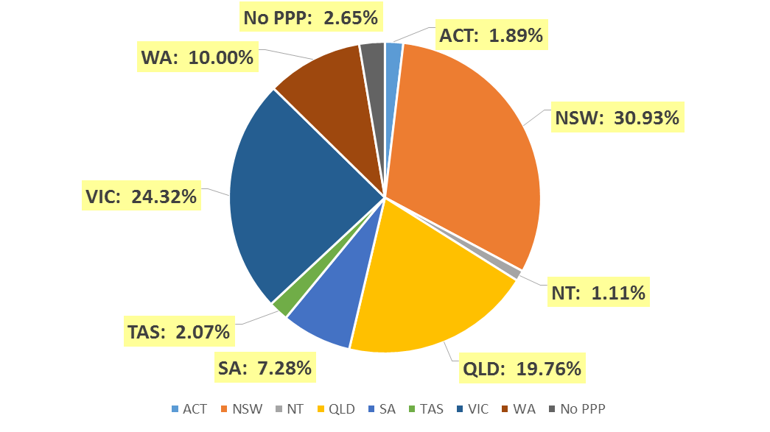
- Specialist Registration
  - Medical practitioners - by area of specialist practice
Specialty Name | Field of Specialty Practice | ACT | NSW | NT | QLD | SA | TAS | VIC | WA | No PPP | Total
Addiction medicine |  | 4 | 66 | 4 | 28 | 15 | 6 | 28 | 13 | 3 | 167
Anaesthesia |  | 79 | 1,429 | 35 | 961 | 364 | 110 | 1,121 | 530 | 135 | 4,764
Dermatology |  | 6 | 185 | 2 | 88 | 45 | 7 | 139 | 44 | 10 | 526
Emergency medicine |  | 40 | 499 | 36 | 452 | 117 | 48 | 494 | 224 | 67 | 1,977
General practice |  | 447 | 7,543 | 255 | 5,190 | 1,920 | 611 | 5,876 | 2,509 | 216 | 24,567
Intensive care medicine | Paediatric intensive care medicine |  | 3 |  | 1 |  | 1 | 3 |  |  | 8
Intensive care medicine | No sub-specialty declared | 22 | 243 | 9 | 184 | 74 | 15 | 192 | 79 | 37 | 855
Sub Total |  | 22 | 246 | 9 | 185 | 74 | 16 | 195 | 79 | 37 | 863
Medical administration |  | 9 | 109 | 3 | 79 | 14 | 5 | 71 | 25 | 12 | 327
Obstetrics and gynaecology | Gynaecological oncology |  | 15 |  | 9 | 4 | 1 | 12 | 4 |  | 45
Obstetrics and gynaecology | Maternal-fetal medicine | 1 | 12 | 1 | 8 | 3 |  | 9 | 5 | 1 | 40
Obstetrics and gynaecology | Obstetrics and gynaecological ultrasound |  | 12 |  | 5 | 3 |  | 48 | 3 | 2 | 73
Obstetrics and gynaecology | Reproductive endocrinology and infertility |  | 27 |  | 3 | 7 | 1 | 14 | 2 |  | 54
Obstetrics and gynaecology | Urogynaecology | 1 | 9 |  | 8 | 1 |  | 8 | 4 |  | 31
Obstetrics and gynaecology | No sub-specialty declared | 33 | 487 | 13 | 341 | 130 | 38 | 433 | 157 | 53 | 1,685
Sub Total |  | 35 | 562 | 14 | 374 | 148 | 40 | 524 | 175 | 56 | 1,928
Occupational and environmental medicine |  | 15 | 89 | 1 | 41 | 31 | 7 | 65 | 46 | 11 | 306
Ophthalmology |  | 15 | 367 | 4 | 165 | 67 | 22 | 247 | 82 | 22 | 991
Continued on next page

Specialty Name | Field of Specialty Practice | ACT | NSW | NT | QLD | SA | TAS | VIC | WA | No PPP | Total
Paediatrics and child health | Clinical genetics |  | 17 |  | 5 |  |  | 6 | 1 |  | 29
Paediatrics and child health | Community child health | 2 | 23 |  | 12 | 2 |  | 12 | 4 | 1 | 56
Paediatrics and child health | General paediatrics | 29 | 614 | 23 | 342 | 135 | 31 | 451 | 181 | 33 | 1,839
Paediatrics and child health | Neonatal and perinatal medicine | 5 | 47 | 2 | 29 | 12 | 3 | 43 | 27 | 5 | 173
Paediatrics and child health | Paediatric cardiology |  | 9 | 1 | 7 |  |  | 10 | 4 | 6 | 37
Paediatrics and child health | Paediatric clinical pharmacology |  | 1 |  |  |  |  |  |  |  | 1
Paediatrics and child health | Paediatric emergency medicine |  | 13 |  | 18 | 5 |  | 10 | 10 | 2 | 58
Paediatrics and child health | Paediatric endocrinology | 1 | 13 |  | 9 |  |  | 5 | 4 |  | 32
Paediatrics and child health | Paediatric gastroenterology and hepatology |  | 5 |  | 4 | 1 |  | 9 | 5 | 3 | 27
Paediatrics and child health | Paediatric haematology |  | 4 |  | 2 |  |  | 4 | 2 |  | 12
Paediatrics and child health | Paediatric immunology and allergy | 1 | 7 |  | 4 | 4 |  | 8 |  |  | 24
Paediatrics and child health | Paediatric infectious diseases |  | 4 | 1 | 5 | 2 |  | 7 | 3 | 1 | 23
Paediatrics and child health | Paediatric intensive care medicine |  | 3 |  | 3 |  |  |  |  |  | 6
Paediatrics and child health | Paediatric medical oncology |  | 5 |  | 8 | 2 |  | 9 | 6 | 2 | 32
Paediatrics and child health | Paediatric nephrology |  | 4 |  | 1 | 1 |  | 3 | 1 |  | 10
Paediatrics and child health | Paediatric neurology |  | 18 |  | 5 | 1 | 1 | 7 | 2 | 2 | 36
Paediatrics and child health | Paediatric nuclear medicine |  | 1 |  |  |  |  |  |  |  | 1
Paediatrics and child health | Paediatric palliative medicine |  | 1 |  | 1 |  |  | 1 |  |  | 3
Paediatrics and child health | Paediatric rehabilitation medicine |  | 4 |  | 2 | 1 |  |  | 1 |  | 8
Paediatrics and child health | Paediatric respiratory and sleep medicine | 1 | 10 |  | 9 | 1 |  | 4 | 4 |  | 29
Paediatrics and child health | Paediatric rheumatology |  | 3 |  | 2 | 1 |  | 2 | 3 |  | 11
Paediatrics and child health | No sub-specialty declared | 3 | 34 | 8 | 12 | 11 | 4 | 50 | 20 | 18 | 160
Sub Total |  | 42 | 840 | 35 | 480 | 179 | 39 | 641 | 278 | 73 | 2,607
Continued on next page

Specialty Name |  | Field of Specialty Practice | ACT | NSW | NT | QLD |  | SA | TAS | VIC | WA | No PPP | Total
Pain medicine |  |  | 5 | 92 |  | 56 |  | 28 | 10 | 52 | 33 | 3 | 279
Palliative medicine |  |  | 5 | 108 | 4 | 53 |  | 24 | 12 | 67 | 31 | 6 | 310
Pathology | Anatomical pathology(incl cytopathology) |  | 18 | 304 | 4 | 173 |  | 64 | 20 | 197 | 98 | 14 | 892
Pathology | Chemical pathology |  | 4 | 25 | 1 | 14 |  | 8 | 2 | 19 | 16 | 3 | 92
Pathology | Forensic pathology |  |  | 9 | 1 | 13 |  | 5 | 2 | 12 | 5 |  | 47
Pathology | General pathology |  | 1 | 50 |  | 18 |  | 5 | 4 | 24 | 6 | 2 | 110
Pathology | Haematology |  | 11 | 165 | 3 | 92 |  | 44 | 10 | 135 | 43 | 7 | 510
Pathology | Immunology |  | 6 | 46 |  | 12 |  | 11 | 1 | 20 | 18 | 1 | 115
Pathology | Microbiology |  | 6 | 81 | 1 | 40 |  | 16 | 5 | 45 | 36 | 3 | 233
Pathology | No sub-specialty declared |  | 2 | 17 |  | 9 |  | 3 |  | 6 | 9 | 3 | 49
Sub Total |  |  | 48 | 697 | 10 | 371 | 156 |  | 44 | 458 | 231 | 33 | 2,048
Physician | Cardiology |  | 18 | 423 | 6 | 260 |  | 117 | 20 | 346 | 86 | 46 | 1,322
Physician | Clinical genetics |  |  | 30 |  | 7 |  | 8 |  | 20 | 4 | 1 | 70
Physician | Clinical pharmacology |  | 1 | 14 |  | 10 |  | 11 |  | 11 | 5 | 3 | 55
Physician | Endocrinology |  | 14 | 215 | 7 | 119 |  | 33 | 10 | 207 | 50 | 4 | 659
Physician | Gastroenterology and hepatology |  | 23 | 252 | 4 | 156 |  | 62 | 14 | 244 | 66 | 19 | 840
Physician | General medicine |  | 30 | 383 | 19 | 370 |  | 232 | 32 | 509 | 136 | 41 | 1,752
Physician | Geriatric medicine |  | 13 | 217 | 2 | 96 |  | 51 | 11 | 202 | 76 | 6 | 674
Physician | Haematology |  | 10 | 170 | 3 | 92 |  | 39 | 10 | 154 | 39 | 11 | 528
Physician | Immunology and allergy |  | 7 | 59 | 1 | 16 |  | 13 | 2 | 31 | 25 | 5 | 159
Physician | Infectious diseases |  | 9 | 97 | 10 | 64 |  | 30 | 7 | 153 | 35 | 11 | 416
Physician | Medical oncology |  | 12 | 187 | 2 | 105 |  | 48 | 11 | 213 | 38 | 13 | 629
Physician | Nephrology |  | 14 | 162 | 12 | 86 |  | 25 | 10 | 166 | 40 | 17 | 532
Physician | Neurology |  | 9 | 210 | 2 | 74 |  | 38 | 7 | 179 | 45 | 10 | 574
Physician | Nuclear medicine |  | 7 | 103 |  | 29 |  | 24 | 6 | 59 | 21 | 2 | 251
Physician | Respiratory and sleep medicine |  | 10 | 208 | 2 | 126 |  | 57 | 13 | 174 | 64 | 8 | 662
Physician | Rheumatology |  | 9 | 117 | 1 | 47 |  | 35 | 7 | 106 | 30 | 7 | 359
Physician | No sub-specialty declared |  | 5 | 124 | 4 | 31 |  | 9 | 8 | 48 | 57 | 15 | 301
Sub Total |  |  | 191 | 2,971 | 75 | 1,688 |  | 832 | 168 | 2,822 | 817 | 219 | 9,783
Continued on next page

Specialty Name | Field of Specialty Practice | ACT | NSW | NT | QLD | SA | TAS | VIC | WA | No PPP | Total
Psychiatry |  | 58 | 1,079 | 21 | 674 | 288 | 64 | 993 | 312 | 80 | 3,569
Public health medicine |  | 29 | 132 | 23 | 78 | 27 | 10 | 77 | 42 | 13 | 431
Radiation Oncology |  | 13 | 134 | 2 | 76 | 19 | 9 | 98 | 20 | 7 | 378
Radiology | Diagnostic radiology | 39 | 598 | 3 | 380 | 164 | 43 | 493 | 209 | 104 | 2,033
Radiology | Diagnostic ultrasound |  | 1 |  |  |  |  | 3 |  |  | 4
Radiology | Nuclear medicine | 4 | 39 |  | 47 | 10 | 2 | 66 | 10 | 2 | 180
Radiology | No sub-specialty declared | 5 | 44 | 1 | 12 | 4 | 3 | 48 | 23 | 16 | 156
Sub Total |  | 48 | 682 | 4 | 439 | 178 | 48 | 610 | 242 | 122 | 2,373
Rehabilitation medicine |  | 6 | 229 | 2 | 64 | 37 | 8 | 135 | 14 | 7 | 502
Sexual health medicine |  | 4 | 58 | 1 | 18 | 9 | 1 | 24 | 7 | 1 | 123
Sport and exercise medicine |  | 11 | 41 | 1 | 11 | 4 | 2 | 39 | 10 | 1 | 120
Surgery | Cardio-thoracic surgery | 5 | 54 |  | 39 | 12 | 4 | 62 | 15 | 9 | 200
Surgery | General surgery | 26 | 656 | 19 | 355 | 158 | 34 | 524 | 153 | 47 | 1,972
Surgery | Neurosurgery | 7 | 78 |  | 48 | 16 | 5 | 68 | 18 | 5 | 245
Surgery | Oral and maxillofacial surgery | 3 | 29 | 1 | 32 | 12 | 2 | 28 | 14 | 4 | 125
Surgery | Orthopaedic surgery | 26 | 435 | 7 | 301 | 118 | 26 | 313 | 133 | 32 | 1,391
Surgery | Otolaryngology - head and neck surgery | 8 | 161 | 2 | 91 | 44 | 9 | 122 | 44 | 11 | 492
Surgery | Paediatric surgery | 5 | 35 |  | 14 | 8 | 2 | 22 | 8 | 5 | 99
Surgery | Plastic surgery | 5 | 132 | 2 | 69 | 41 | 11 | 141 | 47 | 2 | 450
Surgery | Urology | 7 | 133 | 1 | 85 | 30 | 10 | 120 | 41 | 5 | 432
Surgery | Vascular surgery | 4 | 73 | 1 | 45 | 17 | 4 | 62 | 18 | 4 | 228
Surgery | No sub-specialty declared |  | 30 | 1 | 2 |  |  | 12 | 3 | 1 | 49
Sub Total |  | 96 | 1,816 | 34 | 1,081 | 456 | 107 | 1,474 | 494 | 125 | 5,683
Total |  | 1,228 | 19,974 | 575 | 12,652 | 5,032 | 1,394 | 16,250 | 6,258 | 1,259 | 64,622

- Endorsements by Type
  - Medical practitioners – endorsements by state or territory
Endorsement | ACT | NSW | NT | QLD | SA | TAS | VIC | WA | No PPP | Total
Acupuncture | 5 | 158 | 3 | 87 | 34 | 12 | 229 | 36 |  | 564

Medical practitioners by age group
- Age by Registration Type
  - Medical practitioners - registration type by age group
Age Group | General | General (TA) | General and Specialist | General (TA) and Specialist | Specialist | Provisional | Limited | Non-practising | Total
U - 25 | 128 |  |  |  |  | 796 | 1 |  | 925
25 - 29 | 9,044 |  | 55 |  | 6 | 3,089 | 94 | 62 | 12,350
30 - 34 | 11,271 |  | 1,618 |  | 221 | 874 | 584 | 191 | 14,759
35 - 39 | 6,311 | 2 | 5,800 |  | 1,064 | 417 | 738 | 200 | 14,532
40 - 44 | 3,157 | 1 | 7,444 |  | 1,888 | 183 | 538 | 217 | 13,428
45 - 49 | 1,935 | 1 | 6,905 | 1 | 1,935 | 81 | 292 | 216 | 11,366
50 - 54 | 1,420 | 4 | 6,884 |  | 1,666 | 40 | 157 | 235 | 10,406
55 - 59 | 1,087 | 8 | 7,099 |  | 1,112 | 19 | 63 | 245 | 9,633
60 - 64 | 719 | 5 | 6,079 |  | 632 | 10 | 39 | 265 | 7,749
65 - 69 | 470 | 6 | 4,376 |  | 314 | 3 | 12 | 282 | 5,463
70 - 74 | 348 | 4 | 2,636 |  | 102 |  | 4 | 283 | 3,377
75 - 79 | 240 | 2 | 1,202 |  | 35 |  | 1 | 243 | 1,723
80+ | 216 | 3 | 604 |  | 7 |  |  | 302 | 1,132
Total | 36,346 | 36 | 50,702 | 1 | 8,982 | 5,512 | 2,523 | 2,741 | 106,843

  - Medical practitioners – by age group
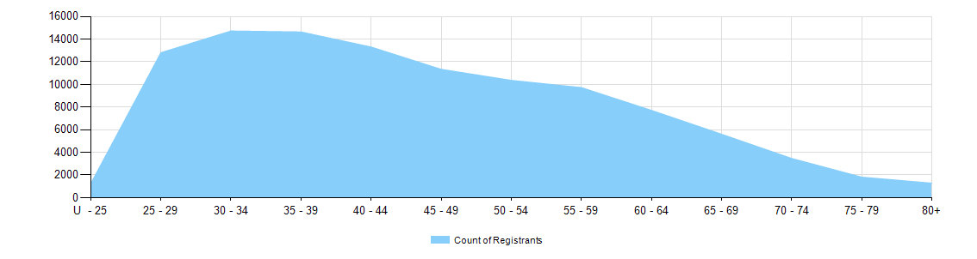

  - Medical practitioners - limited registration by age group
Medical Practitioners | Limited Registration
Age Group | Area of need | Postgraduate training or supervised practice | Public interest | Teaching or research | Total
U - 25 |  | 1 |  |  | 1
25 - 29 | 19 | 75 |  |  | 94
30 - 34 | 154 | 429 |  | 1 | 584
35 - 39 | 209 | 526 |  | 3 | 738
40 - 44 | 212 | 318 |  | 8 | 538
45 - 49 | 143 | 147 |  | 2 | 292
50 - 54 | 94 | 57 |  | 6 | 157
55 - 59 | 35 | 27 |  | 1 | 63
60 - 64 | 26 | 11 |  | 2 | 39
65 - 69 | 8 | 2 | 1 | 1 | 12
70 - 74 | 3 | 1 |  |  | 4
75 - 79 | 1 |  |  |  | 1
80+
Total | 904 | 1,594 | 1 | 24 | 2,523

Medical practitioners by gender
- Gender by registration type
  - Medical practitioners - gender by state and territory by registration type
Gender | Registration Type | Registration Sub-type | ACT | NSW | NT | QLD | SA | TAS | VIC | WA | No PPP | Total
Female | General |  | 398 | 5,915 | 272 | 3,606 | 1,259 | 331 | 4,519 | 1,943 | 334 | 18,577
Female | General (TA) |  |  | 8 |  | 2 | 1 | 2 | 2 | 1 |  | 16
Female | General TA and Specialist |  |  | 1 |  |  |  |  |  |  |  | 1
Female | General and Specialist |  | 367 | 5,829 | 198 | 3,295 | 1,363 | 414 | 4,785 | 1,532 | 227 | 18,010
Female | Specialist |  | 69 | 710 | 34 | 728 | 174 | 67 | 619 | 454 | 131 | 2,986
Female | Provisional |  | 60 | 782 | 47 | 674 | 212 | 60 | 636 | 349 | 20 | 2,840
Female | Limited | Postgraduate training or supervised practice | 10 | 224 | 2 | 92 | 51 | 14 | 138 | 80 | 12 | 623
Female | Limited | Area of need | 5 | 41 | 17 | 67 | 31 | 16 | 138 | 68 |  | 383
Female | Limited | Teaching or research |  | 1 |  | 1 | 2 |  | 2 | 4 |  | 10
Female | Non-practising |  | 15 | 295 | 4 | 103 | 54 | 22 | 204 | 83 | 352 | 1,132
Total Female |  |  | 924 | 13,806 | 574 | 8,568 | 3,147 | 926 | 11,043 | 4,514 | 1,076 | 44,578
Male | General |  | 318 | 5,741 | 235 | 3,722 | 1,196 | 314 | 4,088 | 1,713 | 442 | 17,769
Male | General TA |  |  | 3 |  | 9 | 1 |  | 7 |  |  | 20
Male | General TA and Specialist
Male | General and Specialist |  | 569 | 10,696 | 227 | 6,177 | 2,640 | 676 | 8,361 | 2,873 | 473 | 32,692
Male | Specialist |  | 111 | 1,296 | 76 | 1,492 | 399 | 147 | 1,203 | 929 | 343 | 5,996
Male | Provisional |  | 56 | 709 | 41 | 735 | 183 | 54 | 547 | 328 | 19 | 2,672
Male | Limited | Postgraduate training or supervised practice | 14 | 334 | 10 | 137 | 93 | 30 | 241 | 104 | 8 | 971
Male | Limited | Area of need | 5 | 57 | 21 | 91 | 32 | 27 | 195 | 93 |  | 521
Male | Limited | Public interest |  |  | 1 |  |  |  |  |  |  | 1
Male | Limited | Teaching or research |  | 5 | 1 | 4 | 1 |  | 1 | 2 |  | 14
Male | Non-practising |  | 20 | 398 | 5 | 174 | 81 | 34 | 299 | 123 | 475 | 1,609
Total Male |  |  | 1,093 | 19,239 | 617 | 12,541 | 4,626 | 1,282 | 14,942 | 6,165 | 1,760 | 62,265
Total |  |  | 2,017 | 33,045 | 1,191 | 21,109 | 7,773 | 2,208 | 25,985 | 10,679 | 2,836 | 106,843
- Gender percentages
  - Medical practitioners – percentage by gender
Gender | ACT | NSW | NT | QLD | SA | TAS | VIC | WA | No PPP | Total
Female | 45.8% | 41.8% | 48.2% | 40.6% | 40.5% | 41.9% | 42.5% | 42.3% | 37.9% | 41.7%
Male | 54.2% | 58.2% | 51.8% | 59.4% | 59.5% | 58.1% | 57.5% | 57.7% | 62.1% | 58.3%

