

Medical Board of Australia

Registrant data

Reporting period: 1 January 2018 – 31 March 2018

Table of contents
Introduction 3
Medical practitioners by state and territory 4
1. Registration type 4
2. Specialist registration 5
3. Endorsements by type 8
Medical practitioners by age group 9
4. Age by registration type 9
Medical practitioners by gender 11
5. Gender by registration type 11
6. Gender percentages 12

Introduction
The role of the Medical Board of Australia (the Board) is to:
- register medical practitioners and medical students
- develop standards, codes and guidelines for the medical profession
- investigate notifications and complaints
- where necessary, conduct panel hearings and refer serious matters to Tribunal hearings
- oversee the assessment of overseas trained practitioners who wish to practise in Australia, and
- approve accreditation standards and accredited courses of study.
The Board’s functions are supported by the Australian Health Practitioner Regulation Agency (AHPRA). For information about legislation governing our operations see About AHPRA at http://www.ahpra.gov.au/About-AHPRA/What-We-Do/Legislation.aspx.
The Board has analysed its registration data and produced a number of statistical breakdowns about registrants to share with the profession and community. The Board shares these breakdowns quarterly.
For more information on medical registration, please see the Board’s website: http://www.medicalboard.gov.au/Registration.aspx

Medical practitioners by state and territory
- Registration type
  - Medical practitioners – registration type by state or territory
Registration Type | Registration Sub-type | ACT | NSW | NT | QLD | SA | TAS | VIC | WA | No PPP | Total
General |  | 793 | 12,804 | 558 | 8,462 | 2,695 | 740 | 9,658 | 4,079 | 799 | 40,588
General (Teaching and Assessing) (TA) |  |  | 10 |  | 11 | 1 | 3 | 12 | 2 |  | 39
General TA and Specialist |  |  | 1 |  |  |  |  |  |  |  | 1
General and Specialist |  | 994 | 17,327 | 493 | 10,186 | 4,138 | 1,156 | 13,874 | 4,675 | 728 | 53,571
Specialist |  | 183 | 2,129 | 129 | 2,396 | 600 | 235 | 1,997 | 1,504 | 509 | 9,682
Provisional |  | 106 | 1,515 | 101 | 1,257 | 475 | 119 | 1,202 | 685 | 76 | 5,536
Limited | Postgraduate training or supervised practice | 31 | 589 | 15 | 237 | 142 | 53 | 475 | 186 | 29 | 1,757
Limited | Area of need | 6 | 71 | 31 | 94 | 42 | 25 | 279 | 108 |  | 656
Limited | Public interest |  | 1 |  |  |  |  |  |  |  | 1
Limited | Teaching or research |  | 10 |  | 6 | 4 |  | 4 | 8 | 1 | 33
Non-practising |  | 33 | 721 | 12 | 284 | 145 | 53 | 529 | 212 | 822 | 2,811
Total |  | 2,146 | 35,178 | 1,339 | 22,933 | 8,242 | 2,384 | 28,030 | 11,459 | 2,964 | 114,675
  - Medical practitioners – percentage by state or territory
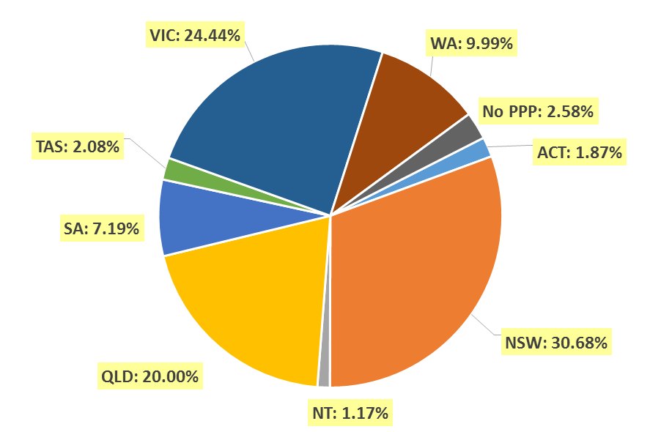
- Specialist registration
  - Medical practitioners – by area of specialist practice
Specialty name | Field of specialty practice | ACT | NSW | NT | QLD | SA | TAS | VIC | WA | No PPP | Total
Addiction medicine |  | 4 | 68 | 2 | 31 | 15 | 6 | 29 | 16 | 4 | 175
Anaesthesia |  | 82 | 1,518 | 37 | 1,040 | 381 | 118 | 1,197 | 556 | 140 | 5,069
Dermatology |  | 6 | 196 | 2 | 96 | 46 | 6 | 149 | 44 | 9 | 554
Emergency medicine |  | 41 | 587 | 46 | 520 | 130 | 48 | 554 | 247 | 74 | 2,247
General practice |  | 471 | 7,755 | 306 | 5,483 | 1,972 | 650 | 6,128 | 2,690 | 232 | 25,687
Intensive care medicine | No sub-specialty declared | 22 | 251 | 12 | 199 | 69 | 17 | 214 | 79 | 35 | 898
Intensive care medicine | Paediatric intensive care medicine |  | 3 |  | 5 |  | 1 | 4 |  |  | 13
Subtotal - Intensive care medicine |  | 22 | 254 | 12 | 204 | 69 | 18 | 218 | 79 | 35 | 911
Medical administration |  | 10 | 104 | 4 | 82 | 15 | 8 | 68 | 25 | 12 | 328
Obstetrics and gynaecology | Gynaecological oncology |  | 15 |  | 10 | 4 | 1 | 12 | 4 |  | 46
Obstetrics and gynaecology | Maternal-fetal medicine | 1 | 12 | 1 | 10 | 3 |  | 9 | 4 | 1 | 41
Obstetrics and gynaecology | Obstetrics and gynaecological ultrasound |  | 13 |  | 3 | 3 |  | 44 | 3 | 2 | 68
Obstetrics and gynaecology | Reproductive endocrinology and infertility |  | 26 |  | 4 | 7 | 1 | 14 | 2 |  | 54
Obstetrics and gynaecology | Urogynaecology | 1 | 10 |  | 7 | 1 |  | 7 | 5 |  | 31
Obstetrics and gynaecology | No sub-specialty declared | 37 | 500 | 14 | 368 | 130 | 39 | 461 | 159 | 49 | 1,757
Subtotal - Obstetrics and gynaecology |  | 39 | 576 | 15 | 402 | 148 | 41 | 547 | 177 | 52 | 1,997
Occupational and environmental medicine |  | 18 | 89 | 1 | 42 | 28 | 5 | 63 | 47 | 9 | 302
Ophthalmology |  | 15 | 374 | 7 | 163 | 70 | 23 | 255 | 81 | 20 | 1,008
Continued on next page

Specialty name | Field of specialty practice | ACT | NSW | NT | QLD | SA | TAS | VIC | WA | No PPP | Total
Paediatrics and child health | Clinical genetics |  | 18 |  | 5 | 1 |  | 9 | 2 |  | 35
Paediatrics and child health | Community child health | 3 | 28 |  | 15 | 2 | 1 | 14 | 4 | 1 | 68
Paediatrics and child health | General paediatrics | 28 | 658 | 28 | 371 | 135 | 34 | 475 | 197 | 37 | 1,963
Paediatrics and child health | Neonatal and perinatal medicine | 7 | 53 |  | 32 | 14 | 3 | 51 | 30 | 5 | 195
Paediatrics and child health | Paediatric cardiology |  | 9 | 1 | 9 |  |  | 10 | 5 | 6 | 40
Paediatrics and child health | Paediatric clinical pharmacology |  | 1 |  |  |  |  |  |  |  | 1
Paediatrics and child health | Paediatric emergency medicine |  | 12 | 1 | 23 | 5 |  | 12 | 12 | 1 | 66
Paediatrics and child health | Paediatric endocrinology | 1 | 14 | 1 | 9 | 2 |  | 3 | 5 | 1 | 36
Paediatrics and child health | Paediatric gastroenterology and hepatology |  | 6 |  | 6 | 1 |  | 12 | 6 | 2 | 33
Paediatrics and child health | Paediatric haematology |  | 5 |  | 5 | 1 |  | 3 | 3 | 1 | 18
Paediatrics and child health | Paediatric immunology and allergy | 1 | 9 |  | 4 | 8 |  | 10 |  |  | 32
Paediatrics and child health | Paediatric infectious diseases |  | 6 | 1 | 7 | 2 |  | 6 | 5 | 2 | 29
Paediatrics and child health | Paediatric intensive care medicine |  | 3 |  | 4 |  |  |  |  |  | 7
Paediatrics and child health | Paediatric medical oncology |  | 9 |  | 10 | 1 |  | 11 | 8 | 2 | 41
Paediatrics and child health | Paediatric nephrology |  | 4 |  | 1 | 2 |  | 4 | 2 |  | 13
Paediatrics and child health | Paediatric neurology |  | 19 |  | 6 | 2 | 1 | 8 | 2 | 3 | 41
Paediatrics and child health | Paediatric nuclear medicine |  | 1 |  |  |  |  |  |  |  | 1
Paediatrics and child health | Paediatric palliative medicine |  | 1 |  | 2 |  |  | 2 |  |  | 5
Paediatrics and child health | Paediatric rehabilitation medicine |  | 4 |  | 2 | 1 |  |  | 2 |  | 9
Paediatrics and child health | Paediatric respiratory and sleep medicine | 2 | 13 |  | 11 | 1 |  | 5 | 7 |  | 39
Paediatrics and child health | Paediatric rheumatology |  | 3 |  | 2 | 1 |  | 3 | 3 |  | 12
Paediatrics and child health | No sub-specialty declared | 2 | 37 | 7 | 15 | 11 | 3 | 53 | 20 | 16 | 164
Subtotal - Paediatrics and child health |  | 44 | 913 | 39 | 539 | 190 | 42 | 691 | 313 | 77 | 2,848
Continued on next page

Specialty name | Field of specialty practice |  | ACT | NSW | NT | QLD | SA | TAS | VIC | WA | No PPP | Total
Pain medicine |  |  | 4 | 97 |  | 57 | 31 | 11 | 61 | 34 | 2 | 297
Palliative medicine |  |  | 4 | 120 | 4 | 62 | 26 | 13 | 78 | 35 | 6 | 348
Pathology |  | Anatomical pathology (incl cytopathology) | 21 | 316 | 7 | 193 | 66 | 19 | 203 | 98 | 15 | 938
 |  | Chemical pathology | 4 | 25 | 1 | 13 | 9 | 2 | 18 | 14 | 3 | 89
 |  | Forensic pathology |  | 11 |  | 16 | 5 | 2 | 14 | 5 |  | 53
 |  | General pathology | 1 | 48 |  | 20 | 4 | 3 | 19 | 6 | 2 | 103
 |  | Haematology | 12 | 177 | 2 | 100 | 42 | 13 | 141 | 46 | 13 | 546
 |  | Immunology | 6 | 50 |  | 14 | 10 |  | 21 | 19 | 1 | 121
 |  | Microbiology | 7 | 87 | 1 | 42 | 17 | 5 | 44 | 36 | 3 | 242
 |  | No sub-specialty declared | 2 | 20 |  | 7 | 3 |  | 7 | 8 | 3 | 50
Subtotal - Pathology |  |  | 53 | 734 | 11 | 405 | 156 | 44 | 467 | 232 | 40 | 2,142
Physician |  | Cardiology | 21 | 454 | 9 | 283 | 115 | 22 | 368 | 92 | 47 | 1,411
 |  | Clinical genetics |  | 32 |  | 7 | 9 |  | 20 | 3 |  | 71
 |  | Clinical pharmacology |  | 16 |  | 10 | 12 |  | 12 | 5 | 3 | 58
 |  | Endocrinology | 14 | 240 | 7 | 134 | 39 | 11 | 224 | 56 | 4 | 729
 |  | Gastroenterology and hepatology | 24 | 277 | 4 | 171 | 64 | 14 | 262 | 74 | 22 | 912
 |  | General medicine | 32 | 380 | 25 | 400 | 234 | 41 | 532 | 149 | 37 | 1,830
 |  | Geriatric medicine | 14 | 253 | 2 | 107 | 63 | 11 | 239 | 86 | 5 | 780
 |  | Haematology | 11 | 180 | 3 | 101 | 39 | 16 | 174 | 41 | 16 | 581
 |  | Immunology and allergy | 8 | 65 | 1 | 15 | 11 | 2 | 33 | 26 | 4 | 165
 |  | Infectious diseases | 10 | 110 | 13 | 68 | 33 | 9 | 169 | 37 | 12 | 461
 |  | Medical oncology | 13 | 213 | 3 | 115 | 49 | 15 | 239 | 43 | 17 | 707
 |  | Nephrology | 13 | 180 | 14 | 96 | 28 | 10 | 181 | 43 | 15 | 580
 |  | Neurology | 10 | 231 | 1 | 85 | 39 | 8 | 205 | 44 | 11 | 634
 |  | Nuclear medicine | 8 | 107 |  | 30 | 25 | 7 | 60 | 22 | 1 | 260
 |  | Respiratory and sleep medicine | 12 | 231 | 1 | 134 | 62 | 13 | 187 | 70 | 10 | 720
 |  | Rheumatology | 11 | 121 | 1 | 54 | 37 | 9 | 112 | 30 | 6 | 381
 |  | No sub-specialty declared | 4 | 110 | 4 | 31 | 6 | 7 | 49 | 53 | 15 | 279
Subtotal - Physician |  |  | 205 | 3,200 | 88 | 1,841 | 865 | 195 | 3,066 | 874 | 225 | 10,559
Continued on next page
Specialty name | Field of specialty practice | ACT | NSW | NT | QLD | SA | TAS | VIC | WA | No PPP | Total
Psychiatry |  | 58 | 1,153 | 24 | 733 | 302 | 74 | 1,049 | 351 | 81 | 3,825
Public health medicine |  | 31 | 128 | 23 | 79 | 26 | 9 | 77 | 41 | 12 | 426
Radiation Oncology |  | 13 | 139 | 3 | 76 | 17 | 8 | 99 | 25 | 8 | 388
Radiology | Diagnostic radiology | 44 | 623 | 2 | 413 | 160 | 42 | 513 | 227 | 113 | 2,137
Radiology | Diagnostic ultrasound |  |  |  | 1 |  |  | 3 |  |  | 4
Radiology | Nuclear medicine | 6 | 38 |  | 51 | 10 | 2 | 69 | 11 | 3 | 190
Radiology | No sub-specialty declared | 8 | 53 |  | 16 | 5 | 2 | 60 | 24 | 18 | 186
Subtotal - Radiology |  | 58 | 714 | 2 | 481 | 175 | 46 | 645 | 262 | 134 | 2,517
Rehabilitation medicine |  | 7 | 237 | 2 | 71 | 38 | 11 | 142 | 15 | 10 | 533
Sexual health medicine |  | 4 | 57 | 1 | 21 | 10 | 2 | 25 | 8 | 1 | 129
Sport and exercise medicine |  | 12 | 42 | 1 | 11 | 4 | 2 | 39 | 10 | 1 | 122
Surgery | Cardio-thoracic surgery | 4 | 56 |  | 42 | 12 | 3 | 59 | 15 | 9 | 200
Surgery | General surgery | 29 | 665 | 21 | 369 | 163 | 33 | 545 | 157 | 51 | 2,033
Surgery | Neurosurgery | 7 | 81 | 1 | 52 | 16 | 7 | 68 | 19 | 5 | 256
Surgery | Oral and maxillofacial surgery | 3 | 35 | 2 | 34 | 13 | 2 | 36 | 14 | 5 | 144
Surgery | Orthopaedic surgery | 26 | 453 | 6 | 321 | 125 | 27 | 327 | 136 | 36 | 1,457
Surgery | Otolaryngology - head and neck surgery | 7 | 169 | 2 | 97 | 45 | 9 | 126 | 43 | 13 | 511
Surgery | Paediatric surgery | 4 | 36 |  | 16 | 9 | 2 | 23 | 8 | 3 | 101
Surgery | Plastic surgery | 5 | 131 | 2 | 73 | 43 | 10 | 147 | 47 | 7 | 465
Surgery | Urology | 7 | 135 | 1 | 91 | 34 | 12 | 128 | 40 | 7 | 455
Surgery | Vascular surgery | 3 | 77 | 2 | 46 | 19 | 4 | 65 | 20 | 3 | 239
Surgery | No sub-specialty declared |  | 24 | 1 |  |  |  | 11 | 5 | 3 | 44
Subtotal - Surgery |  | 95 | 1,862 | 38 | 1,141 | 479 | 109 | 1,535 | 504 | 142 | 5,905
Total |  | 1,296 | 20,917 | 668 | 13,580 | 5,193 | 1,489 | 17,182 | 6,666 | 1,326 | 68,317

- Endorsements by type
  - Medical practitioners – endorsements by state or territory
Endorsement | ACT | NSW | NT | QLD | SA | TAS | VIC | WA | No PPP | Total
Acupuncture | 6 | 166 | 4 | 98 | 32 | 14 | 230 | 37 |  | 587

Medical practitioners by age group
- Age by registration type
  - Medical practitioners – registration type by age group
Age group | General | General (TA) | General and Specialist | General (TA) and Specialist | Specialist | Provisional | Limited | Non-practising | Total
U - 25 | 640 |  |  |  |  | 1,215 |  | 1 | 1,856
25 - 29 | 11,284 |  | 96 |  | 8 | 2,717 | 65 | 61 | 14,231
30 - 34 | 12,093 | 2 | 2,231 |  | 237 | 846 | 582 | 197 | 16,188
35 - 39 | 6,536 | 3 | 6,416 |  | 997 | 440 | 810 | 200 | 15,402
40 - 44 | 3,358 |  | 7,872 |  | 1,948 | 174 | 490 | 214 | 14,056
45 - 49 | 1,997 | 1 | 7,322 | 1 | 2,128 | 79 | 263 | 219 | 12,010
50 - 54 | 1,481 | 4 | 6,870 |  | 1,830 | 35 | 130 | 210 | 10,560
55 - 59 | 1,132 | 7 | 7,115 |  | 1,253 | 17 | 66 | 280 | 9,870
60 - 64 | 806 | 5 | 6,355 |  | 741 | 5 | 31 | 279 | 8,222
65 - 69 | 494 | 5 | 4,477 |  | 345 | 7 | 8 | 280 | 5,616
70 - 74 | 351 | 8 | 2,916 |  | 147 | 1 | 2 | 308 | 3,733
75 - 79 | 217 | 3 | 1,249 |  | 36 |  |  | 262 | 1,767
80+ | 199 | 1 | 652 |  | 12 |  |  | 300 | 1,164
Total | 40,588 | 39 | 53,571 | 1 | 9,682 | 5,536 | 2,447 | 2,811 | 114,675

  - Medical practitioners – by age group

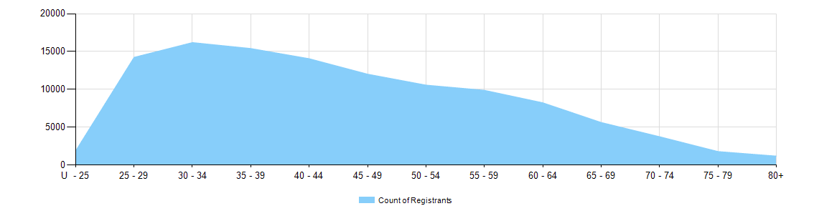

  - Medical practitioners – limited registration by age group
Medical practitioners | Limited registration
Age group | Area of need | Postgraduate training or supervised practice | Public interest | Teaching or research | Total
U - 25 |  |  |  |  | 0
25 - 29 | 5 | 59 |  | 1 | 65
30 - 34 | 86 | 489 |  | 7 | 582
35 - 39 | 168 | 638 |  | 4 | 810
40 - 44 | 155 | 328 |  | 7 | 490
45 - 49 | 109 | 150 | 1 | 3 | 263
50 - 54 | 76 | 48 |  | 6 | 130
55 - 59 | 31 | 34 |  | 1 | 66
60 - 64 | 21 | 8 |  | 2 | 31
65 - 69 | 4 | 2 |  | 2 | 8
70 - 74 | 1 | 1 |  |  | 2
75 - 79 |  |  |  |  | 0
80+ |  |  |  |  | 0
Total | 656 | 1,757 | 1 | 33 | 2,447

Medical practitioners by gender
- Gender by registration type
  - Medical practitioners – gender by state and territory by registration type
Gender | Registration type | Registration subtype | ACT | NSW | NT | QLD | SA | TAS | VIC | WA | No PPP | Total
Female | General |  | 435 | 6,545 | 294 | 4,160 | 1,413 | 379 | 5,073 | 2,150 | 346 | 20,795
Female | General (TA) |  |  | 8 |  | 3 | 1 | 2 | 4 | 1 |  | 19
Female | General TA and Specialist |  |  | 1 |  |  |  |  |  |  |  | 1
Female | General and Specialist |  | 408 | 6,321 | 238 | 3,690 | 1,476 | 453 | 5,230 | 1,700 | 244 | 19,760
Female | Specialist |  | 72 | 767 | 37 | 802 | 189 | 78 | 685 | 513 | 149 | 3,292
Female | Provisional |  | 59 | 774 | 67 | 632 | 261 | 61 | 630 | 381 | 36 | 2,901
Female | Limited | Postgraduate training or supervised practice | 8 | 240 | 7 | 95 | 52 | 21 | 193 | 75 | 13 | 704
Female | Limited | Area of need | 3 | 31 | 13 | 30 | 18 | 9 | 112 | 47 |  | 263
Female | Limited | Teaching or research |  |  |  | 2 | 1 |  | 3 | 8 |  | 14
Female | Non-practising |  | 13 | 323 | 6 | 119 | 56 | 23 | 211 | 92 | 355 | 1,198
Total female |  |  | 998 | 15,010 | 662 | 9,533 | 3,467 | 1,026 | 12,141 | 4,967 | 1,143 | 48,947
Male | General |  | 358 | 6,259 | 264 | 4,302 | 1,282 | 361 | 4,585 | 1,929 | 453 | 19,793
Male | General TA |  |  | 2 |  | 8 |  | 1 | 8 | 1 |  | 20
Male | General and Specialist |  | 586 | 11,006 | 255 | 6,496 | 2,662 | 703 | 8,644 | 2,975 | 484 | 33,811
Male | Specialist |  | 111 | 1,362 | 92 | 1,594 | 411 | 157 | 1,312 | 991 | 360 | 6,390
Male | Provisional |  | 47 | 741 | 34 | 625 | 214 | 58 | 571 | 304 | 40 | 2,634
Male | Limited | Postgraduate training or supervised practice | 23 | 349 | 8 | 142 | 90 | 32 | 282 | 111 | 16 | 1,053
Male | Limited | Area of need | 3 | 40 | 18 | 64 | 24 | 16 | 167 | 61 |  | 393
Male | Limited | Public interest |  | 1 |  |  |  |  |  |  |  | 1
Male | Limited | Teaching or research |  | 10 |  | 4 | 3 |  | 1 |  | 1 | 19
Male | Non-practising |  | 20 | 398 | 6 | 165 | 89 | 30 | 318 | 120 | 467 | 1,613
Total male |  |  | 1,148 | 20,168 | 677 | 13,400 | 4,775 | 1,358 | 15,888 | 6,492 | 1,821 | 65,727
Continued on next page

Gender | Registration type | Registration subtype | ACT | NSW | NT | QLD | SA | TAS | VIC | WA | No PPP | Total
Intersex or Indeterminate | Provisional |  |  |  |  |  |  |  | 1 |  |  | 1
Total Intersex or Indeterminate |  |  |  |  |  |  |  |  | 1 |  |  | 1
Total |  |  | 2,146 | 35,178 | 1,339 | 22,933 | 8,242 | 2,384 | 28,030 | 11,459 | 2,964 | 114,675

- Gender percentages
  - Medical practitioners – percentage by gender
Gender | ACT | NSW | NT | QLD | SA | TAS | VIC | WA | No PPP | Total
Female | 46.5% | 42.7% | 49.4% | 41.6% | 42.1% | 43.0% | 43.3% | 43.3% | 38.6% | 42.7%
Male | 53.5% | 57.3% | 50.6% | 58.4% | 57.9% | 57.0% | 56.7% | 56.7% | 61.4% | 57.3%
Intersex or Indeterminate |  |  |  |  |  |  | <0.1% |  |  | <0.1%

