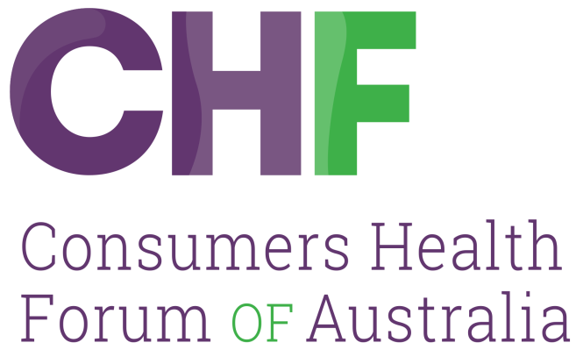



SUBMISSION

GOOD MEDICAL PRACTICE:
A CODE OF CONDUCT FOR DOCTORS IN AUSTRALIA

August 2018

Consumers Shaping Health
Consumers Health Forum of Australia (2018) Good Medical Practice: a code of conduct for doctors in Australia. Canberra, Australia
P: 02 6273 5444
E: info@chf.org.au
twitter.com/CHFofAustralia
facebook.com/CHFofAustralia
Office Address
7B/17 Napier Close,
Deakin ACT 2600
Postal Address
PO Box 73
Deakin West ACT 2600
Consumers Health Forum of Australia is funded by the Australian Government as the peak healthcare consumer organisation under the Health Peak and Advisory Bodies Programme

CONTENTS
Contents

Introduction 4
Key Issues 4
2.1 Professional values and qualities of doctors 4
3.3 Shared decision-making 5
4.2 Doctor-patient partnership 5
4.5 Informed consent 5
4.6 Children and young people 5
4.10 Relatives, carers and partners 6
4.13 End-of-life care 6
5.3 Teamwork 6
6.3 Delegation, referral and handover 6
7.2 Wise use of healthcare resources 6
10.5 Medical records 6
12.4 Medical students 7

Introduction
The Consumers Health Forum of Australia (CHF) is the national peak body representing the interests of Australian healthcare consumers and those with an interest in health consumer affairs. CHF works to achieve safe, quality, timely and affordable healthcare for all Australians, supported by accessible health information and systems.
The Code of Conduct is as important for consumers as it is for doctors: its guidance on expected standards of professional and ethical conduct should give consumer assurance about what they can expect from their doctor. To achieve that goal, it needs to make clear and unambiguous statements about not only behaviours and practices but also values and culture within medical practice which are not open to different interpretations. CHF supports the view from the AMA that the current draft does not meet that requirement and many sections need to be tightened up to give consumers the certainty they are looking for. We identify some of those in our specific comments below.
We do not think the current Code of Conduct puts the consumer at the centre of care and does not explicitly mention that access to appropriate medical care is a human right. We support the recommendation from the Grattan Institute that there should be explicit mention of the Australian Charter of Healthcare Rights as this would be a clear signal that consumers rights are going to be respected.
Our comments concentrate on looking at the Code of Conduct from a consumer perspective and putting the consumer at the centre of care of medical care and practice.

Key Issues

2.1 Professional values and qualities of doctors
We support the notion that “there are certain professional values that underpin good medical practice” and that the code is designed to embed those in doctor’s practice and behaviour.
We agree that community trust and confidence in the medical profession is essential. However, we do not support the notion that “If making public comment you should acknowledge the profession’s generally accepted views and indicate when your personal opinion differs.”
We note that the AMA and Catholic Health Australia have both raised serious objections to this section of the Code and we support their view that this is a serious erosion of doctors’ right to freedom of speech and to fully participate in civil society. Trying to inhibit them speaking on a broad range of issues takes away their capacity to be leaders in the community and takes away their capacity to advocate for reforms and against injustices.
On some issues there is no overwhelming professional position. Issues such as voluntary euthanasia have doctors who are for and those who are against and they should be able to express their view. Indeed, the debate on such issues is often enriched by having medical views put for both sides of the argument and this should not be curtailed in anyway by the code.
We can see that doctors speaking out on some medical issues and promoting views that are not accepted by the majority of their profession e.g doctors who make anti-immunisation statements, could undermine community trust in the profession and cause confusion. However, the blanket approach taken here is too broad and too heavy handed. There needs to be a more nuanced approach.

3.3 Shared decision-making
There may be circumstances when a doctor thinks it would be beneficial to involve family, carers or others in discussions about health care. This section could include a provision for the doctor initiating a discussion with the patient about involving others rather than leaving it just to the patient to initiate. This would obviously be a judgement by the doctor as to whether such a suggestion is a good idea and they should always abide by the decision subject to any formal substitute decision maker being involved.
It would also be good to see some mention here of using shared decision-making tools, where available.

4.2 Doctor-patient partnership
CHF wants consumers to be empowered to take more responsibility for their care and it is good this concept is reflected in this section. One of the key messages from the Choosing Wisely campaign is that consumers should ask their doctors questions about their care to make informed decisions. Section 4.2.5 goes part of the way to addressing this, but it would be better to have an explicit statement that it is the expectation that contemporary medical practice is to encourage questions from patients and to answering the in good faith and on the best available evidence. Strong statements about the role of shared decision making and patients as partners in care would also align the code’s expectations with the evidence that such practices lead to better health decisions, outcomes and patient experience. It would also align with standards in other related spheres such as the National Health Safety and Quality Standards.

4.5 Informed consent
There are serious shortcomings with the approach to fees and out of pocket costs. It is important that 4.5.3 includes the information on fees and charges is available before an appointment. Consumers want to know the fees before they see a doctor as once they have seen them and established a therapeutic relationship it is hard to change doctor to go to someone with a lower fee.
There has been quite a bit of discussion around out of pocket costs and the barrier they put to accessing appropriate care. There are moves to put in place measures which will make doctors’ fees more transparent. The referring doctor is the gatekeeper to other services and they need to take more responsibility for that referral. As a minimum 4.5.4 could require doctors to give patients some details about out of pocket, by telling them how to get the information they want about fees and encouraging them to discuss it with their private health insurer if they have one.

4.6 Children and young people
This section should also include something about letting a young person know that they can see a doctor without an adult present once they are of an age to do so and supporting them in that decision. They also need to guarantee confidentiality of a young person’s information and only share with family/parents when consent has been given. This is partially covered in 4.6.3 but it is not explicit enough.

4.10 Relatives, carers and partners

4.10.1 needs to be strengthened to say that relatives, carers and partners views will be sought and they will be listened to as they can give useful insights into the patient’s condition and response to treatment. This would all require consent from the patient.

4.13 End-of-life care
This is an important section and is the one where the statements need to be more explicit. It is probably one of the areas of practice where sections 3.4.6 and 3.4.7 come into play.
4.13.5 should include a statement about respecting any advance care directive that exists.
4.13.8 should say encouraging and facilitating advance care planning as that makes it a more active approach to getting patients and their families to think about these issues.

5.3 Teamwork
This needs to make it clearer that roles change within a team and that sometimes the doctor is the leader and sometimes someone else is, who may not be a doctor depending on the circumstances. This could be achieved by adding the idea of roles changing into 5.3. 2..

6.3 Delegation, referral and handover
It would be useful to separate delegation out from referral and handover. There is a significant difference between delegation and the others in that the doctor delegating still retains responsibility for management of the patient. Giving it a separate heading would highlight that important difference.

7.2 Wise use of healthcare resources
It is not clear what wise means in this context and this needs some clarification. From the dot points below it appears to be talking about the doctor’s role in the stewardship of the health system and so it should probably say so.
We have several initiatives now looking at minimising the delivery of low value care. These include Choosing Wisely Australia, Evolve and the MBS Review. This section should include a reference to doctors ensuring their practice does not include delivering low value care and that they work with initiatives to reduce waste in the health system that is caused by delivering low value care.

10.5 Medical records
It is somewhat surprising that this section does not include any reference to putting information into electronic health records such as the current My Health Record. The My Health Record is becoming opt-out for consumers who will be looking to their doctors to load information up to it if they have a record. The Code of Conduct should provide some guidance as to how doctors will respond to such a request.
Section 10.5.7 needs to be strengthened and should say that doctors will ensure that patients are able to access their records when they want to see them. Similarly, there should be a stronger statement about the transfer of information that explicitly addresses the transfer of information when a patient chooses to change doctor.

12.4 Medical students
We would like to see 12.4.3 amended to include discussing with patients their concerns about having a medical student involved in the consultation. We think this discussion can be instrumental in encouraging more patients to agree to students participating in consultations.

