

Medical Board of Australia

Registrant data

Reporting period: 1 April 2018 – 30 June 2018

Table of contents
Introduction 3
Medical practitioners by state and territory 4
1. Registration type 4
2. Specialist registration 5
3. Endorsements by type 8
Medical practitioners by age group 9
4. Age by registration type 9
Medical practitioners by gender 11
5. Gender by registration type 11
6. Gender percentages 12

Introduction
The role of the Medical Board of Australia (the Board) is to:
- register medical practitioners and medical students
- develop standards, codes and guidelines for the medical profession
- investigate notifications and complaints
- where necessary, conduct panel hearings and refer serious matters to Tribunal hearings
- oversee the assessment of overseas trained practitioners who wish to practise in Australia, and
- approve accreditation standards and accredited courses of study.
The Board’s functions are supported by the Australian Health Practitioner Regulation Agency (AHPRA). For information about legislation governing our operations see About AHPRA at http://www.ahpra.gov.au/About-AHPRA/What-We-Do/Legislation.aspx.
The Board has analysed its registration data and produced a number of statistical breakdowns about registrants to share with the profession and community. The Board shares these breakdowns quarterly.
For more information on medical registration, please see the Board’s website: http://www.medicalboard.gov.au/Registration.aspx

Medical practitioners by state and territory
- Registration type
  - Medical practitioners – registration type by state or territory
Registration Type | Registration Sub-type | ACT | NSW | NT | QLD | SA | TAS | VIC | WA | No PPP | Total
General |  | 790 | 12,694 | 560 | 8,409 | 2,671 | 734 | 9,608 | 4,072 | 814 | 40,352
General (Teaching and Assessing) (TA) |  |  | 10 |  | 11 | 1 | 3 | 12 | 2 |  | 39
General TA and Specialist |  |  | 1 |  |  |  |  |  |  |  | 1
General and Specialist |  | 1,002 | 17,481 | 498 | 10,321 | 4,172 | 1,171 | 13,989 | 4,727 | 733 | 54,094
Specialist |  | 184 | 2,159 | 131 | 2,426 | 604 | 240 | 2,046 | 1,528 | 517 | 9,835
Provisional |  | 106 | 1,530 | 100 | 1,230 | 475 | 116 | 1,216 | 670 | 71 | 5,514
Limited | Postgraduate training or supervised practice | 30 | 639 | 17 | 250 | 142 | 59 | 463 | 186 | 28 | 1,814
Limited | Area of need | 8 | 62 | 29 | 95 | 44 | 24 | 275 | 101 | 1 | 639
Limited | Public interest |  | 1 |  |  |  |  |  |  |  | 1
Limited | Teaching or research |  | 4 |  | 3 | 3 |  | 4 | 7 | 1 | 22
Non-practising |  | 34 | 722 | 11 | 282 | 144 | 53 | 532 | 208 | 816 | 2,802
Total |  | 2,154 | 35,303 | 1,346 | 23,027 | 8,256 | 2,400 | 28,145 | 11,501 | 2,981 | 115,113
  - Medical practitioners – percentage by state or territory
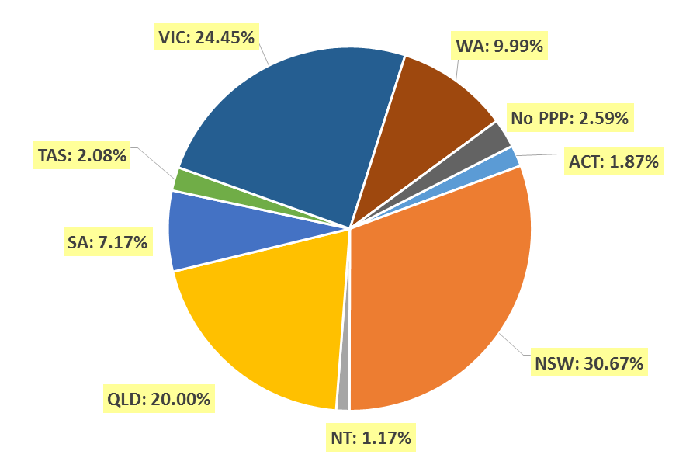
- Specialist registration
  - Medical practitioners – by area of specialist practice
Specialty name | Field of specialty practice | ACT | NSW | NT | QLD | SA | TAS | VIC | WA | No PPP | Total
Addiction medicine |  | 4 | 70 | 2 | 31 | 15 | 6 | 29 | 16 | 4 | 177
Anaesthesia |  | 82 | 1,522 | 37 | 1,048 | 382 | 119 | 1,208 | 564 | 144 | 5,106
Dermatology |  | 6 | 196 | 2 | 96 | 46 | 6 | 149 | 44 | 9 | 554
Emergency medicine |  | 43 | 604 | 47 | 543 | 131 | 49 | 558 | 251 | 75 | 2,301
General practice |  | 475 | 7,833 | 305 | 5,553 | 1,990 | 659 | 6,204 | 2,727 | 234 | 25,980
Intensive care medicine | No sub-specialty declared | 23 | 258 | 13 | 200 | 69 | 17 | 214 | 78 | 36 | 908
Intensive care medicine | Paediatric intensive care medicine |  | 3 |  | 5 |  | 1 | 4 | 1 |  | 14
Subtotal - Intensive care medicine |  | 23 | 261 | 13 | 205 | 69 | 18 | 218 | 79 | 36 | 922
Medical administration |  | 10 | 105 | 4 | 83 | 15 | 8 | 69 | 25 | 12 | 331
Obstetrics and gynaecology | Gynaecological oncology |  | 14 |  | 11 | 4 | 1 | 12 | 4 |  | 46
Obstetrics and gynaecology | Maternal-fetal medicine | 1 | 12 | 1 | 11 | 3 |  | 9 | 4 | 1 | 42
Obstetrics and gynaecology | Obstetrics and gynaecological ultrasound |  | 13 |  | 3 | 3 |  | 44 | 3 | 2 | 68
Obstetrics and gynaecology | Reproductive endocrinology and infertility |  | 26 |  | 4 | 7 | 1 | 14 | 2 |  | 54
Obstetrics and gynaecology | Urogynaecology | 1 | 10 |  | 9 | 1 |  | 7 | 4 |  | 32
Obstetrics and gynaecology | No sub-specialty declared | 37 | 511 | 15 | 374 | 131 | 39 | 472 | 163 | 49 | 1,791
Subtotal - Obstetrics and gynaecology |  | 39 | 586 | 16 | 412 | 149 | 41 | 558 | 180 | 52 | 2,033
Occupational and environmental medicine |  | 18 | 90 | 1 | 42 | 28 | 5 | 64 | 47 | 9 | 304
Ophthalmology |  | 15 | 378 | 7 | 168 | 71 | 23 | 257 | 81 | 20 | 1,020
Continued on next page

Specialty name | Field of specialty practice | ACT | NSW | NT | QLD | SA | TAS | VIC | WA | No PPP | Total
Paediatrics and child health | Clinical genetics |  | 19 |  | 5 | 1 |  | 9 | 2 |  | 36
Paediatrics and child health | Community child health | 3 | 28 |  | 15 | 2 | 1 | 14 | 4 | 1 | 68
Paediatrics and child health | General paediatrics | 28 | 665 | 27 | 372 | 137 | 36 | 479 | 200 | 38 | 1,982
Paediatrics and child health | Neonatal and perinatal medicine | 7 | 55 | 1 | 34 | 14 | 3 | 54 | 31 | 4 | 203
Paediatrics and child health | Paediatric cardiology |  | 9 | 1 | 11 |  |  | 10 | 5 | 6 | 42
Paediatrics and child health | Paediatric clinical pharmacology |  | 1 |  |  |  |  |  |  |  | 1
Paediatrics and child health | Paediatric emergency medicine |  | 13 | 1 | 21 | 6 |  | 17 | 12 | 1 | 71
Paediatrics and child health | Paediatric endocrinology | 1 | 14 | 1 | 9 | 2 |  | 3 | 5 | 1 | 36
Paediatrics and child health | Paediatric gastroenterology and hepatology |  | 6 |  | 6 | 1 |  | 11 | 6 | 3 | 33
Paediatrics and child health | Paediatric haematology |  | 5 |  | 5 | 1 |  | 4 | 3 | 1 | 19
Paediatrics and child health | Paediatric immunology and allergy | 1 | 9 |  | 4 | 9 |  | 10 | 2 |  | 35
Paediatrics and child health | Paediatric infectious diseases |  | 7 | 1 | 7 | 2 |  | 6 | 5 | 2 | 30
Paediatrics and child health | Paediatric intensive care medicine |  | 3 |  | 4 |  |  |  |  |  | 7
Paediatrics and child health | Paediatric medical oncology |  | 9 |  | 11 | 1 |  | 12 | 8 | 1 | 42
Paediatrics and child health | Paediatric nephrology |  | 4 |  | 1 | 2 |  | 4 | 2 |  | 13
Paediatrics and child health | Paediatric neurology |  | 17 |  | 6 | 2 | 1 | 9 | 2 | 3 | 40
Paediatrics and child health | Paediatric nuclear medicine |  | 1 |  |  |  |  |  |  |  | 1
Paediatrics and child health | Paediatric palliative medicine |  | 1 |  | 2 |  |  | 2 |  |  | 5
Paediatrics and child health | Paediatric rehabilitation medicine |  | 4 |  | 2 | 1 |  |  | 2 |  | 9
Paediatrics and child health | Paediatric respiratory and sleep medicine | 2 | 15 |  | 11 | 1 |  | 5 | 7 |  | 41
Paediatrics and child health | Paediatric rheumatology |  | 3 |  | 2 | 1 |  | 3 | 3 | 1 | 13
Paediatrics and child health | No sub-specialty declared | 2 | 38 | 7 | 17 | 11 | 3 | 53 | 19 | 14 | 164
Subtotal - Paediatrics and child health |  | 44 | 926 | 39 | 545 | 194 | 44 | 705 | 318 | 76 | 2,891
Continued on next page

Specialty name | Field of specialty practice |  | ACT | NSW | NT | QLD | SA | TAS | VIC | WA | No PPP | Total
Pain medicine |  |  | 5 | 99 |  | 60 | 31 | 11 | 62 | 34 | 2 | 304
Palliative medicine |  |  | 4 | 120 | 4 | 63 | 26 | 13 | 79 | 35 | 6 | 350
Pathology |  | Anatomical pathology (incl cytopathology) | 20 | 318 | 7 | 194 | 66 | 19 | 204 | 98 | 14 | 940
 |  | Chemical pathology | 4 | 25 | 1 | 13 | 10 | 2 | 18 | 14 | 4 | 91
 |  | Forensic pathology |  | 11 |  | 16 | 5 | 2 | 15 | 5 |  | 54
 |  | General pathology | 1 | 48 |  | 20 | 4 | 3 | 19 | 6 | 2 | 103
 |  | Haematology | 12 | 177 | 2 | 100 | 43 | 13 | 143 | 48 | 13 | 551
 |  | Immunology | 6 | 49 |  | 14 | 10 |  | 21 | 20 | 1 | 121
 |  | Microbiology | 7 | 89 | 1 | 42 | 17 | 5 | 45 | 36 | 3 | 245
 |  | No sub-specialty declared | 2 | 20 |  | 8 | 3 |  | 7 | 8 | 3 | 51
Subtotal - Pathology |  |  | 52 | 737 | 11 | 407 | 158 | 44 | 472 | 235 | 40 | 2,156
Physician |  | Cardiology | 21 | 457 | 10 | 287 | 115 | 22 | 373 | 93 | 47 | 1,425
 |  | Clinical genetics |  | 32 |  | 7 | 9 |  | 20 | 3 |  | 71
 |  | Clinical pharmacology |  | 16 |  | 10 | 13 |  | 12 | 5 | 3 | 59
 |  | Endocrinology | 14 | 242 | 7 | 135 | 40 | 11 | 225 | 56 | 5 | 735
 |  | Gastroenterology and hepatology | 24 | 280 | 5 | 171 | 64 | 16 | 263 | 75 | 22 | 920
 |  | General medicine | 30 | 385 | 27 | 403 | 237 | 41 | 536 | 152 | 35 | 1,846
 |  | Geriatric medicine | 13 | 257 | 2 | 110 | 63 | 12 | 244 | 87 | 4 | 792
 |  | Haematology | 11 | 179 | 3 | 102 | 40 | 16 | 175 | 43 | 16 | 585
 |  | Immunology and allergy | 8 | 64 | 1 | 15 | 12 | 2 | 33 | 27 | 4 | 166
 |  | Infectious diseases | 10 | 111 | 13 | 69 | 33 | 9 | 170 | 38 | 11 | 464
 |  | Medical oncology | 14 | 217 | 4 | 118 | 51 | 15 | 237 | 44 | 17 | 717
 |  | Nephrology | 13 | 181 | 14 | 98 | 28 | 10 | 182 | 43 | 15 | 584
 |  | Neurology | 10 | 231 | 1 | 86 | 39 | 8 | 207 | 44 | 13 | 639
 |  | Nuclear medicine | 8 | 107 |  | 30 | 25 | 7 | 60 | 22 | 1 | 260
 |  | Respiratory and sleep medicine | 12 | 232 | 1 | 134 | 62 | 13 | 190 | 70 | 10 | 724
 |  | Rheumatology | 11 | 122 | 2 | 54 | 37 | 9 | 112 | 30 | 7 | 384
 |  | No sub-specialty declared | 4 | 110 | 4 | 30 | 6 | 7 | 48 | 51 | 14 | 274
Subtotal - Physician |  |  | 203 | 3,223 | 94 | 1,859 | 874 | 198 | 3,087 | 883 | 224 | 10,645
Continued on next page
Specialty name | Field of specialty practice | ACT | NSW | NT | QLD | SA | TAS | VIC | WA | No PPP | Total
Psychiatry |  | 60 | 1,163 | 25 | 749 | 302 | 77 | 1,062 | 352 | 82 | 3,872
Public health medicine |  | 32 | 131 | 22 | 79 | 26 | 10 | 77 | 42 | 13 | 432
Radiation Oncology |  | 13 | 142 | 3 | 76 | 18 | 9 | 100 | 25 | 8 | 394
Radiology | Diagnostic radiology | 44 | 629 | 2 | 413 | 160 | 41 | 517 | 229 | 116 | 2,151
Radiology | Diagnostic ultrasound |  |  |  | 1 |  |  | 3 |  |  | 4
Radiology | Nuclear medicine | 6 | 38 |  | 51 | 10 | 2 | 69 | 11 | 3 | 190
Radiology | No sub-specialty declared | 8 | 54 |  | 19 | 5 | 2 | 60 | 24 | 18 | 190
Subtotal - Radiology |  | 58 | 721 | 2 | 484 | 175 | 45 | 649 | 264 | 137 | 2,535
Rehabilitation medicine |  | 7 | 237 | 2 | 73 | 38 | 11 | 142 | 15 | 10 | 535
Sexual health medicine |  | 4 | 57 | 1 | 21 | 10 | 2 | 25 | 8 | 1 | 129
Sport and exercise medicine |  | 12 | 44 | 1 | 11 | 4 | 2 | 39 | 10 | 1 | 124
Surgery | Cardio-thoracic surgery | 4 | 57 |  | 42 | 12 | 3 | 60 | 16 | 9 | 203
Surgery | General surgery | 29 | 669 | 20 | 375 | 164 | 32 | 548 | 161 | 52 | 2,050
Surgery | Neurosurgery | 7 | 81 | 1 | 52 | 16 | 7 | 68 | 19 | 5 | 256
Surgery | Oral and maxillofacial surgery | 3 | 35 | 2 | 34 | 13 | 2 | 36 | 15 | 5 | 145
Surgery | Orthopaedic surgery | 26 | 452 | 6 | 321 | 125 | 28 | 329 | 139 | 37 | 1,463
Surgery | Otolaryngology - head and neck surgery | 7 | 167 | 2 | 98 | 45 | 9 | 126 | 43 | 13 | 510
Surgery | Paediatric surgery | 4 | 36 |  | 16 | 9 | 2 | 24 | 8 | 3 | 102
Surgery | Plastic surgery | 5 | 133 | 2 | 73 | 43 | 10 | 148 | 48 | 6 | 468
Surgery | Urology | 8 | 135 | 1 | 91 | 34 | 12 | 127 | 40 | 7 | 455
Surgery | Vascular surgery | 3 | 77 | 2 | 47 | 19 | 4 | 65 | 20 | 3 | 240
Surgery | No sub-specialty declared |  | 24 | 1 |  |  |  | 11 | 5 | 3 | 44
Subtotal - Surgery |  | 96 | 1,866 | 37 | 1,149 | 480 | 109 | 1,542 | 514 | 143 | 5,936
Total |  | 1,305 | 21,111 | 675 | 13,757 | 5,232 | 1,509 | 17,355 | 6,749 | 1,338 | 69,031

- Endorsements by type
  - Medical practitioners – endorsements by state or territory
Endorsement | ACT | NSW | NT | QLD | SA | TAS | VIC | WA | No PPP | Total
Acupuncture | 5 | 167 | 4 | 99 | 32 | 14 | 234 | 37 |  | 592

Medical practitioners by age group
- Age by registration type
  - Medical practitioners – registration type by age group
Age group | General | General (TA) | General and Specialist | General (TA) and Specialist | Specialist | Provisional | Limited | Non-practising | Total
U - 25 | 430 |  |  |  |  | 1,041 |  |  | 1,471
25 - 29 | 10,830 |  | 117 |  | 8 | 2,794 | 63 | 57 | 13,869
30 - 34 | 12,237 | 2 | 2,240 |  | 226 | 903 | 591 | 183 | 16,382
35 - 39 | 6,682 | 3 | 6,428 |  | 1,001 | 440 | 827 | 197 | 15,578
40 - 44 | 3,381 |  | 8,009 |  | 1,956 | 191 | 494 | 205 | 14,236
45 - 49 | 2,049 | 1 | 7,363 | 1 | 2,139 | 79 | 273 | 227 | 12,132
50 - 54 | 1,487 | 4 | 6,851 |  | 1,876 | 39 | 129 | 210 | 10,596
55 - 59 | 1,140 | 7 | 7,154 |  | 1,294 | 19 | 56 | 270 | 9,940
60 - 64 | 831 | 5 | 6,405 |  | 771 | 3 | 31 | 289 | 8,335
65 - 69 | 506 | 5 | 4,559 |  | 357 | 3 | 10 | 281 | 5,721
70 - 74 | 350 | 7 | 2,991 |  | 150 | 2 | 2 | 312 | 3,814
75 - 79 | 219 | 3 | 1,299 |  | 44 |  |  | 260 | 1,825
80+ | 210 | 2 | 678 |  | 13 |  |  | 311 | 1,214
Total | 40,352 | 39 | 54,094 | 1 | 9,835 | 5,514 | 2,476 | 2,802 | 115,113

  - Medical practitioners – by age group

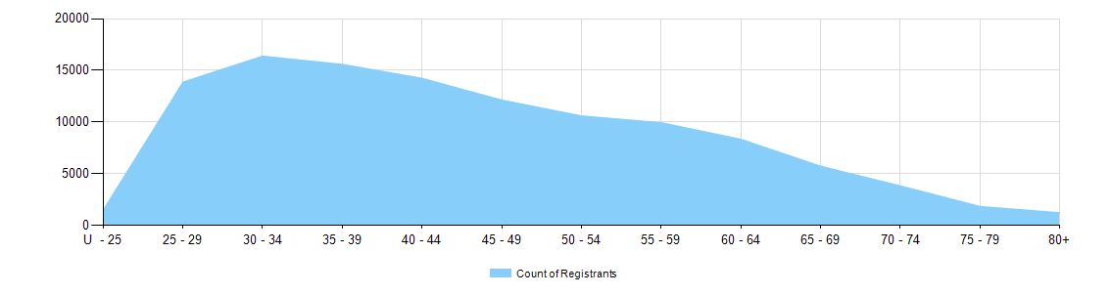

  - Medical practitioners – limited registration by age group
Medical practitioners | Limited registration
Age group | Area of need | Postgraduate training or supervised practice | Public interest | Teaching or research | Total
U - 25
25 - 29 | 3 | 60 |  |  | 63
30 - 34 | 78 | 505 |  | 8 | 591
35 - 39 | 165 | 659 |  | 3 | 827
40 - 44 | 151 | 341 |  | 2 | 494
45 - 49 | 114 | 156 | 1 | 2 | 273
50 - 54 | 70 | 56 |  | 3 | 129
55 - 59 | 31 | 24 |  | 1 | 56
60 - 64 | 20 | 10 |  | 1 | 31
65 - 69 | 7 | 2 |  | 1 | 10
70 - 74 |  | 1 |  | 1 | 2
75 - 79
80+
Total | 639 | 1,814 | 1 | 22 | 2,476

Medical practitioners by gender
- Gender by registration type
  - Medical practitioners – gender by state and territory by registration type
Gender | Registration type | Registration subtype | ACT | NSW | NT | QLD | SA | TAS | VIC | WA | No PPP | Total
Female | General |  | 437 | 6,498 | 303 | 4,129 | 1,397 | 371 | 5,040 | 2,148 | 351 | 20,674
Female | General (TA) |  |  | 8 |  | 3 | 1 | 2 | 4 | 1 |  | 19
Female | General TA and Specialist |  |  | 1 |  |  |  |  |  |  |  | 1
Female | General and Specialist |  | 412 | 6,419 | 237 | 3,758 | 1,497 | 461 | 5,298 | 1,723 | 245 | 20,050
Female | Specialist |  | 72 | 775 | 38 | 818 | 191 | 82 | 708 | 523 | 153 | 3,360
Female | Provisional |  | 60 | 778 | 64 | 622 | 262 | 59 | 641 | 374 | 31 | 2,891
Female | Limited | Postgraduate training or supervised practice | 7 | 264 | 8 | 104 | 50 | 25 | 182 | 73 | 14 | 727
Female | Limited | Area of need | 5 | 29 | 13 | 31 | 20 | 8 | 115 | 44 |  | 265
Female | Limited | Teaching or research |  |  |  | 1 | 1 |  | 3 | 7 |  | 12
Female | Non-practising |  | 14 | 323 | 5 | 116 | 56 | 23 | 211 | 90 | 351 | 1,189
Total female |  |  | 1,007 | 15,095 | 668 | 9,582 | 3,475 | 1,031 | 12,202 | 4,983 | 1,145 | 49,188
Male | General |  | 353 | 6,196 | 257 | 4,280 | 1,274 | 363 | 4,568 | 1,924 | 463 | 19,678
Male | General TA |  |  | 2 |  | 8 |  | 1 | 8 | 1 |  | 20
Male | General and Specialist |  | 590 | 11,062 | 261 | 6,563 | 2,675 | 710 | 8,691 | 3,004 | 488 | 34,044
Male | Specialist |  | 112 | 1,384 | 93 | 1,608 | 413 | 158 | 1,338 | 1,005 | 364 | 6,475
Male | Provisional |  | 46 | 752 | 36 | 608 | 213 | 57 | 574 | 296 | 40 | 2,622
Male | Limited | Postgraduate training or supervised practice | 23 | 375 | 9 | 146 | 92 | 34 | 281 | 113 | 14 | 1,087
Male | Limited | Area of need | 3 | 33 | 16 | 64 | 24 | 16 | 160 | 57 | 1 | 374
Male | Limited | Public interest |  | 1 |  |  |  |  |  |  |  | 1
Male | Limited | Teaching or research |  | 4 |  | 2 | 2 |  | 1 |  | 1 | 10
Male | Non-practising |  | 20 | 399 | 6 | 166 | 88 | 30 | 321 | 118 | 465 | 1,613
Total male |  |  | 1,147 | 20,208 | 678 | 13,445 | 4,781 | 1,369 | 15,942 | 6,518 | 1,836 | 65,924
Continued on next page

Gender | Registration type | Registration subtype | ACT | NSW | NT | QLD | SA | TAS | VIC | WA | No PPP | Total
Intersex or Indeterminate | Provisional |  |  |  |  |  |  |  | 1 |  |  | 1
Total Intersex or Indeterminate |  |  |  |  |  |  |  |  | 1 |  |  | 1
Total |  |  | 2,154 | 35,303 | 1,346 | 23,027 | 8,256 | 2,400 | 28,145 | 11,501 | 2,981 | 115,113

- Gender percentages
  - Medical practitioners – percentage by gender
Gender | ACT | NSW | NT | QLD | SA | TAS | VIC | WA | No PPP | Total
Female | 46.8% | 42.8% | 49.6% | 41.6% | 42.1% | 43.0% | 43.4% | 43.3% | 38.4% | 42.7%
Male | 53.2% | 57.2% | 50.4% | 58.4% | 57.9% | 57.0% | 56.6% | 56.7% | 61.6% | 57.3%
Intersex or Indeterminate |  |  |  |  |  |  | <0.1% |  |  | <0.1%

