

Medical Board of Australia

Registrant data

Reporting period: 1 October 2018 – 31 December 2018

Table of contents
Introduction 3
Medical practitioners by state and territory 4
1. Registration type 4
2. Specialist registration 5
3. Endorsements by type 8
Medical practitioners by age group 9
4. Age by registration type 9
Medical practitioners by gender 11
5. Gender by registration type 11
6. Gender percentages 12

Introduction
The role of the Medical Board of Australia (the Board) is to:
- register medical practitioners and medical students
- develop standards, codes and guidelines for the medical profession
- investigate notifications and complaints
- where necessary, conduct panel hearings and refer serious matters to Tribunal hearings
- oversee the assessment of overseas trained practitioners who wish to practise in Australia, and
- approve accreditation standards and accredited courses of study.
The Board’s functions are supported by the Australian Health Practitioner Regulation Agency (AHPRA). For information about legislation governing our operations see About AHPRA at http://www.ahpra.gov.au/About-AHPRA/What-We-Do/Legislation.aspx.
The Board has analysed its registration data and produced a number of statistical breakdowns about registrants to share with the profession and community. The Board shares these breakdowns quarterly.
For more information on medical registration, please see the Board’s website: http://www.medicalboard.gov.au/Registration.aspx

Medical practitioners by state and territory
- Registration type
  - Medical practitioners – registration type by state or territory
Registration Type | Registration Sub-type | ACT | NSW | NT | QLD | SA | TAS | VIC | WA | No PPP | Total
General |  | 734 | 12,349 | 561 | 8,123 | 2,604 | 736 | 9,419 | 3,949 | 792 | 39,267
General (Teaching and Assessing) (TA) |  |  | 9 |  | 11 | 1 | 3 | 11 | 2 |  | 37
General TA and Specialist |  |  | 1 |  |  |  |  |  |  |  | 1
General and Specialist |  | 1,015 | 17,457 | 513 | 10,428 | 4,175 | 1,187 | 14,097 | 4,770 | 733 | 54,375
Specialist |  | 183 | 2,167 | 128 | 2,489 | 621 | 249 | 2,091 | 1,528 | 503 | 9,959
Provisional |  | 119 | 1,511 | 112 | 1,254 | 458 | 93 | 1,284 | 684 | 102 | 5,617
Limited | Postgraduate training or supervised practice | 28 | 700 | 16 | 271 | 165 | 75 | 471 | 187 | 38 | 1,951
Limited | Area of need | 8 | 58 | 26 | 85 | 36 | 25 | 249 | 83 | 1 | 571
Limited | Public interest |  | 1 |  |  |  |  |  |  |  | 1
Limited | Teaching or research |  | 5 |  | 6 | 2 |  | 6 | 7 | 1 | 27
Non-practising |  | 28 | 691 | 10 | 274 | 144 | 49 | 522 | 197 | 854 | 2,769
Total |  | 2,115 | 34,949 | 1,366 | 22,941 | 8,206 | 2,417 | 28,150 | 11,407 | 3,024 | 114,575
  - Medical practitioners – percentage by state or territory
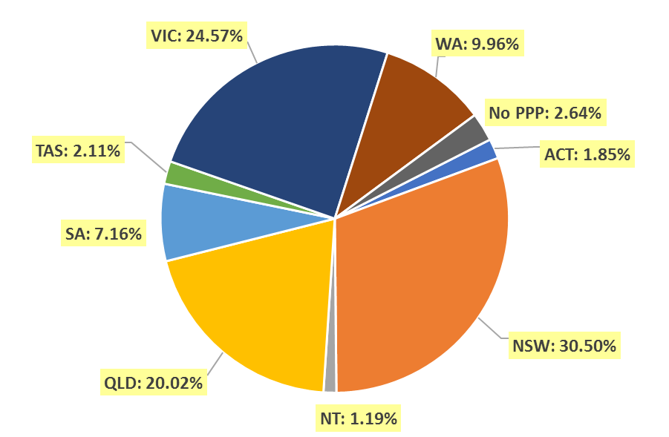

- Specialist registration
  - Medical practitioners – by area of specialist practice
Specialty name | Field of specialty practice | ACT | NSW | NT | QLD | SA | TAS | VIC | WA | No PPP | Total
Addiction medicine |  | 4 | 70 | 3 | 31 | 13 | 5 | 31 | 16 | 4 | 177
Anaesthesia |  | 81 | 1,523 | 37 | 1,063 | 381 | 115 | 1,217 | 565 | 132 | 5,114
Dermatology |  | 6 | 194 | 3 | 96 | 46 | 6 | 150 | 44 | 9 | 554
Emergency medicine | No sub-specialty declared | 47 | 621 | 46 | 552 | 138 | 54 | 571 | 256 | 77 | 2,362
Emergency medicine | Paediatric emergency medicine |  | 2 |  | 4 |  | 1 | 1 |  |  | 8
Subtotal - Emergency medicine |  | 47 | 623 | 46 | 556 | 138 | 55 | 572 | 256 | 77 | 2,370
General practice |  | 479 | 7,796 | 311 | 5,630 | 1,983 | 662 | 6,249 | 2,744 | 245 | 26,099
Intensive care medicine | No sub-specialty declared | 24 | 260 | 12 | 204 | 69 | 17 | 220 | 82 | 39 | 927
Intensive care medicine | Paediatric intensive care medicine |  | 4 |  | 5 |  | 1 | 4 | 1 |  | 15
Subtotal - Intensive care medicine |  | 24 | 264 | 12 | 209 | 69 | 18 | 224 | 83 | 39 | 942
Medical administration |  | 10 | 102 | 4 | 83 | 15 | 7 | 68 | 25 | 11 | 325
Obstetrics and gynaecology | Gynaecological oncology |  | 15 | 1 | 9 | 4 | 1 | 13 | 4 | 1 | 48
Obstetrics and gynaecology | Maternal-fetal medicine | 1 | 12 | 1 | 11 | 3 |  | 9 | 4 | 1 | 42
Obstetrics and gynaecology | Obstetrics and gynaecological ultrasound |  | 12 |  | 3 | 2 |  | 44 | 3 | 2 | 66
Obstetrics and gynaecology | Reproductive endocrinology and infertility |  | 25 | 1 | 4 | 6 | 1 | 14 | 2 |  | 53
Obstetrics and gynaecology | Urogynaecology | 1 | 9 |  | 9 | 1 |  | 7 | 5 |  | 32
Obstetrics and gynaecology | No sub-specialty declared | 36 | 510 | 17 | 370 | 132 | 39 | 465 | 165 | 45 | 1,779
Subtotal - Obstetrics and gynaecology |  | 38 | 583 | 20 | 406 | 148 | 41 | 552 | 183 | 49 | 2,020
Occupational and environmental medicine |  | 16 | 90 | 1 | 43 | 28 | 5 | 62 | 48 | 9 | 302
Ophthalmology |  | 15 | 374 | 7 | 175 | 67 | 23 | 252 | 80 | 17 | 1,010
Continued on next page

Specialty name | Field of specialty practice | ACT | NSW | NT | QLD | SA | TAS | VIC | WA | No PPP | Total
Paediatrics and child health | Clinical genetics |  | 19 |  | 5 |  |  | 10 | 2 |  | 36
Paediatrics and child health | Community child health | 3 | 31 |  | 16 | 2 | 1 | 15 | 5 | 1 | 74
Paediatrics and child health | General paediatrics | 30 | 667 | 27 | 375 | 140 | 36 | 493 | 204 | 37 | 2,009
Paediatrics and child health | Neonatal and perinatal medicine | 6 | 54 | 1 | 36 | 15 | 4 | 54 | 33 | 4 | 207
Paediatrics and child health | Paediatric cardiology |  | 9 | 1 | 11 | 1 |  | 12 | 7 | 4 | 45
Paediatrics and child health | Paediatric clinical pharmacology |  | 1 |  |  |  |  |  |  |  | 1
Paediatrics and child health | Paediatric emergency medicine | 1 | 17 | 1 | 22 | 7 |  | 17 | 12 | 2 | 79
Paediatrics and child health | Paediatric endocrinology | 1 | 16 | 1 | 10 | 2 |  | 3 | 5 | 1 | 39
Paediatrics and child health | Paediatric gastroenterology and hepatology |  | 7 |  | 6 | 1 |  | 12 | 6 | 2 | 34
Paediatrics and child health | Paediatric haematology |  | 5 |  | 5 | 1 |  | 4 | 2 | 2 | 19
Paediatrics and child health | Paediatric immunology and allergy | 1 | 9 |  | 5 | 9 |  | 11 | 2 |  | 37
Paediatrics and child health | Paediatric infectious diseases |  | 7 | 1 | 6 | 2 |  | 6 | 6 | 3 | 31
Paediatrics and child health | Paediatric intensive care medicine |  | 3 | 1 | 3 |  |  |  |  |  | 7
Paediatrics and child health | Paediatric medical oncology | 1 | 10 |  | 12 | 3 |  | 10 | 6 | 3 | 45
Paediatrics and child health | Paediatric nephrology |  | 6 |  | 1 | 2 |  | 4 | 2 | 1 | 16
Paediatrics and child health | Paediatric neurology |  | 17 |  | 6 | 2 | 1 | 12 | 2 | 3 | 43
Paediatrics and child health | Paediatric nuclear medicine |  | 1 |  |  |  |  |  |  |  | 1
Paediatrics and child health | Paediatric palliative medicine |  | 1 |  | 2 |  |  | 2 |  |  | 5
Paediatrics and child health | Paediatric rehabilitation medicine |  | 4 |  | 3 | 1 |  |  | 2 |  | 10
Paediatrics and child health | Paediatric respiratory and sleep medicine | 2 | 16 |  | 11 | 1 |  | 5 | 8 |  | 43
Paediatrics and child health | Paediatric rheumatology |  | 3 |  | 3 | 2 |  | 3 | 4 |  | 15
Paediatrics and child health | No sub-specialty declared | 2 | 39 | 6 | 18 | 12 | 2 | 58 | 17 | 14 | 168
Subtotal - Paediatrics and child health |  | 47 | 942 | 39 | 556 | 203 | 44 | 731 | 325 | 77 | 2,964
Continued on next page

Specialty name | Field of specialty practice | ACT | NSW | NT | QLD | SA | TAS | VIC | WA | No PPP | Total
Pain medicine |  | 5 | 99 |  | 60 | 33 | 12 | 66 | 36 | 3 | 314
Palliative medicine |  | 4 | 121 | 4 | 68 | 26 | 13 | 83 | 39 | 5 | 363
Pathology | Anatomical pathology (including cytopathology) | 18 | 319 | 5 | 191 | 65 | 19 | 199 | 93 | 15 | 924
Pathology | Chemical pathology | 4 | 26 | 1 | 12 | 9 | 2 | 19 | 13 | 4 | 90
Pathology | Forensic pathology |  | 14 |  | 15 | 5 | 2 | 15 | 5 |  | 56
Pathology | General pathology | 1 | 44 |  | 19 | 3 | 3 | 19 | 6 | 2 | 97
Pathology | Haematology | 12 | 176 | 2 | 100 | 42 | 13 | 143 | 46 | 13 | 547
Pathology | Immunology | 6 | 46 |  | 14 | 10 |  | 21 | 17 | 2 | 116
Pathology | Microbiology | 6 | 87 | 1 | 42 | 16 | 6 | 45 | 36 | 2 | 241
Pathology | No sub-specialty declared | 2 | 18 |  | 9 | 3 |  | 8 | 8 | 3 | 51
Subtotal - Pathology |  | 49 | 730 | 9 | 402 | 153 | 45 | 469 | 224 | 41 | 2,122
Physician | Cardiology | 20 | 467 | 11 | 288 | 119 | 26 | 386 | 94 | 45 | 1,456
Physician | Clinical genetics |  | 32 |  | 7 | 8 |  | 21 | 3 |  | 71
Physician | Clinical pharmacology |  | 16 |  | 12 | 14 |  | 13 | 5 | 3 | 63
Physician | Endocrinology | 13 | 239 | 7 | 135 | 41 | 12 | 228 | 58 | 7 | 740
Physician | Gastroenterology and hepatology | 23 | 283 | 5 | 177 | 68 | 13 | 268 | 82 | 18 | 937
Physician | General medicine | 30 | 369 | 25 | 426 | 237 | 42 | 535 | 155 | 34 | 1,853
Physician | Geriatric medicine | 14 | 263 | 2 | 114 | 68 | 13 | 259 | 91 | 5 | 829
Physician | Haematology | 13 | 183 | 3 | 104 | 41 | 16 | 176 | 43 | 15 | 594
Physician | Immunology and allergy | 8 | 64 |  | 17 | 12 | 2 | 31 | 24 | 5 | 163
Physician | Infectious diseases | 10 | 112 | 12 | 70 | 32 | 10 | 171 | 38 | 11 | 466
Physician | Medical oncology | 13 | 224 | 3 | 122 | 51 | 15 | 238 | 46 | 18 | 730
Physician | Nephrology | 15 | 180 | 15 | 98 | 27 | 10 | 188 | 44 | 16 | 593
Physician | Neurology | 10 | 229 | 2 | 94 | 41 | 8 | 214 | 45 | 15 | 658
Physician | Nuclear medicine | 7 | 106 |  | 30 | 25 | 7 | 61 | 22 | 1 | 259
Physician | Respiratory and sleep medicine | 12 | 238 | 1 | 137 | 62 | 13 | 189 | 71 | 8 | 731
Physician | Rheumatology | 11 | 127 | 3 | 56 | 38 | 9 | 116 | 32 | 7 | 399
Physician | No sub-specialty declared | 4 | 106 | 4 | 27 | 6 | 7 | 44 | 48 | 14 | 260
Subtotal - Physician |  | 203 | 3,238 | 93 | 1,914 | 890 | 203 | 3,138 | 901 | 222 | 10,802
Continued on next page
Specialty name | Field of specialty practice | ACT | NSW | NT | QLD | SA | TAS | VIC | WA | No PPP | Total
Psychiatry |  | 68 | 1,140 | 27 | 763 | 297 | 82 | 1,077 | 354 | 81 | 3,889
Public health medicine |  | 30 | 125 | 21 | 84 | 25 | 10 | 75 | 42 | 13 | 425
Radiation Oncology |  | 13 | 143 | 1 | 81 | 19 | 10 | 99 | 24 | 10 | 400
Radiology | Diagnostic radiology | 42 | 634 | 4 | 413 | 164 | 40 | 511 | 229 | 115 | 2,152
Radiology | Diagnostic ultrasound |  |  |  | 1 |  |  | 3 |  |  | 4
Radiology | Nuclear medicine | 5 | 40 |  | 47 | 10 | 2 | 65 | 11 | 1 | 181
Radiology | No sub-specialty declared | 8 | 55 |  | 20 | 4 | 2 | 65 | 22 | 20 | 196
Subtotal - Radiology |  | 55 | 729 | 4 | 481 | 178 | 44 | 644 | 262 | 136 | 2,533
Rehabilitation medicine |  | 7 | 239 | 3 | 73 | 42 | 11 | 147 | 14 | 8 | 544
Sexual health medicine |  | 5 | 56 | 1 | 20 | 10 | 2 | 25 | 8 | 1 | 128
Sport and exercise medicine |  | 12 | 44 | 2 | 11 | 5 | 2 | 39 | 10 | 1 | 126
Surgery | Cardio-thoracic surgery | 4 | 58 |  | 41 | 12 | 4 | 58 | 16 | 10 | 203
Surgery | General surgery | 29 | 663 | 21 | 364 | 163 | 34 | 547 | 159 | 49 | 2,029
Surgery | Neurosurgery | 8 | 80 | 2 | 51 | 18 | 7 | 65 | 19 | 5 | 255
Surgery | Oral and maxillofacial surgery | 4 | 36 | 1 | 36 | 12 | 2 | 38 | 14 | 5 | 148
Surgery | Orthopaedic surgery | 27 | 456 | 5 | 323 | 123 | 28 | 323 | 136 | 30 | 1,451
Surgery | Otolaryngology - head and neck surgery | 7 | 165 | 3 | 96 | 45 | 10 | 123 | 43 | 14 | 506
Surgery | Paediatric surgery | 4 | 37 |  | 15 | 9 | 3 | 24 | 8 | 4 | 104
Surgery | Plastic surgery | 4 | 131 | 2 | 73 | 45 | 12 | 149 | 48 | 6 | 470
Surgery | Urology | 8 | 136 | 1 | 91 | 33 | 12 | 129 | 40 | 6 | 456
Surgery | Vascular surgery | 3 | 78 | 1 | 47 | 20 | 5 | 62 | 20 | 2 | 238
Surgery | No sub-specialty declared |  | 22 | 1 | 1 |  |  | 9 | 5 | 2 | 40
Subtotal - Surgery |  | 98 | 1,862 | 37 | 1,138 | 480 | 117 | 1,527 | 508 | 133 | 5,900
Total |  | 1,316 | 21,087 | 685 | 13,943 | 5,249 | 1,532 | 17,497 | 6,791 | 1,323 | 69,423

- Endorsements by type
  - Medical practitioners – endorsements by state or territory
Endorsement | ACT | NSW | NT | QLD | SA | TAS | VIC | WA | No PPP | Total
Acupuncture | 5 | 165 | 4 | 98 | 30 | 14 | 230 | 35 |  | 581

Medical practitioners by age group
- Age by registration type
  - Medical practitioners – registration type by age group
Age group | General | General (TA) | General and Specialist | General (TA) and Specialist | Specialist | Provisional | Limited | Non-practising | Total
U - 25 | 146 |  |  |  |  | 728 |  |  | 874
25 - 29 | 9,784 |  | 107 |  | 1 | 3,083 | 76 | 60 | 13,111
30 - 34 | 12,432 | 1 | 2,308 |  | 241 | 998 | 603 | 198 | 16,781
35 - 39 | 6,732 | 4 | 6,433 |  | 916 | 469 | 869 | 201 | 15,624
40 - 44 | 3,391 |  | 8,164 |  | 1,916 | 194 | 526 | 202 | 14,393
45 - 49 | 2,051 | 1 | 7,526 | 1 | 2,190 | 88 | 254 | 220 | 12,331
50 - 54 | 1,491 | 4 | 6,835 |  | 1,957 | 26 | 124 | 212 | 10,649
55 - 59 | 1,148 | 4 | 7,177 |  | 1,364 | 23 | 59 | 261 | 10,036
60 - 64 | 843 | 9 | 6,386 |  | 802 | 4 | 26 | 268 | 8,338
65 - 69 | 514 | 3 | 4,600 |  | 373 | 2 | 10 | 288 | 5,790
70 - 74 | 315 | 8 | 2,934 |  | 145 | 2 | 3 | 322 | 3,729
75 - 79 | 229 | 2 | 1,266 |  | 41 |  |  | 255 | 1,793
80+ | 191 | 1 | 639 |  | 13 |  |  | 282 | 1,126
Total | 39,267 | 37 | 54,375 | 1 | 9,959 | 5,617 | 2,550 | 2,769 | 114,575

  - Medical practitioners – by age group
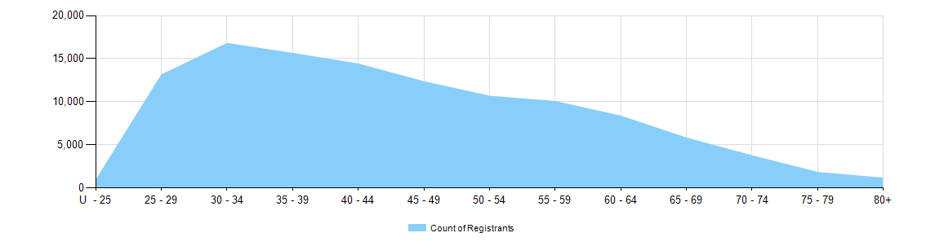

  - Medical practitioners – limited registration by age group
Medical practitioners | Limited registration
Age group | Area of need | Postgraduate training or supervised practice | Public interest | Teaching or research | Total
U - 25 |  |  |  |  | 0
25 - 29 | 3 | 73 |  |  | 76
30 - 34 | 61 | 533 |  | 9 | 603
35 - 39 | 153 | 712 |  | 4 | 869
40 - 44 | 139 | 385 |  | 2 | 526
45 - 49 | 102 | 146 | 1 | 5 | 254
50 - 54 | 60 | 63 |  | 1 | 124
55 - 59 | 30 | 27 |  | 2 | 59
60 - 64 | 16 | 8 |  | 2 | 26
65 - 69 | 7 | 2 |  | 1 | 10
70 - 74 |  | 2 |  | 1 | 3
75 - 79 |  |  |  |  | 0
80+ |  |  |  |  | 0
Total | 571 | 1,951 | 1 | 27 | 2,550

Medical practitioners by gender
- Gender by registration type
  - Medical practitioners – gender by state and territory by registration type
Gender | Registration type | Registration subtype | ACT | NSW | NT | QLD | SA | TAS | VIC | WA | No PPP | Total
Female | General |  | 397 | 6,326 | 321 | 3,951 | 1,345 | 377 | 4,943 | 2,086 | 337 | 20,083
Female | General (TA) |  |  | 7 |  | 4 | 1 | 2 | 5 | 1 |  | 20
Female | General TA and Specialist |  |  | 1 |  |  |  |  |  |  |  | 1
Female | General and Specialist |  | 420 | 6,499 | 238 | 3,856 | 1,529 | 477 | 5,412 | 1,757 | 254 | 20,442
Female | Specialist |  | 72 | 781 | 40 | 852 | 202 | 88 | 710 | 531 | 159 | 3,435
Female | Provisional |  | 67 | 798 | 67 | 666 | 247 | 48 | 690 | 389 | 57 | 3,029
Female | Limited | Postgraduate training or supervised practice | 9 | 309 | 7 | 112 | 60 | 29 | 174 | 76 | 21 | 797
Female | Limited | Area of need | 5 | 27 | 11 | 24 | 13 | 10 | 110 | 35 |  | 235
Female | Limited | Teaching or research |  |  |  | 3 |  |  | 3 | 7 |  | 13
Female | Non-practising |  | 10 | 310 | 6 | 117 | 56 | 21 | 218 | 91 | 369 | 1,198
Total female |  |  | 980 | 15,058 | 690 | 9,585 | 3,453 | 1,052 | 12,265 | 4,973 | 1,197 | 49,253
Male | General |  | 337 | 6,023 | 240 | 4,172 | 1,259 | 359 | 4,476 | 1,863 | 455 | 19,184
Male | General TA |  |  | 2 |  | 7 |  | 1 | 6 | 1 |  | 17
Male | General and Specialist |  | 595 | 10,958 | 275 | 6,572 | 2,646 | 710 | 8,685 | 3,013 | 479 | 33,933
Male | Specialist |  | 111 | 1,386 | 88 | 1,637 | 419 | 161 | 1,381 | 997 | 344 | 6,524
Male | Provisional |  | 52 | 713 | 45 | 588 | 211 | 45 | 593 | 295 | 45 | 2,587
Male | Limited | Postgraduate training or supervised practice | 19 | 391 | 9 | 159 | 105 | 46 | 297 | 111 | 17 | 1,154
Male | Limited | Area of need | 3 | 31 | 15 | 61 | 23 | 15 | 139 | 48 | 1 | 336
Male | Limited | Public interest |  | 1 |  |  |  |  |  |  |  | 1
Male | Limited | Teaching or research |  | 5 |  | 3 | 2 |  | 3 |  | 1 | 14
Male | Non-practising |  | 18 | 381 | 4 | 157 | 88 | 28 | 304 | 106 | 485 | 1,571
Total male |  |  | 1,135 | 19,891 | 676 | 13,356 | 4,753 | 1,365 | 15,884 | 6,434 | 1,827 | 65,321
Continued on next page

Gender | Registration type | Registration subtype | ACT | NSW | NT | QLD | SA | TAS | VIC | WA | No PPP | Total
Intersex or Indeterminate | Provisional |  |  |  |  |  |  |  | 1 |  |  | 1
Total |  |  | 2,115 | 34,949 | 1,366 | 22,941 | 8,206 | 2,417 | 28,150 | 11,407 | 3,024 | 114,575

- Gender percentages
  - Medical practitioners – percentage by gender
Gender | ACT | NSW | NT | QLD | SA | TAS | VIC | WA | No PPP | Total
Female | 46.3% | 43.1% | 50.5% | 41.8% | 42.1% | 43.5% | 43.6% | 43.6% | 39.6% | 43.0%
Male | 53.7% | 56.9% | 49.5% | 58.2% | 57.9% | 56.5% | 56.4% | 56.4% | 60.4% | 57.0%
Intersex or Indeterminate |  |  |  |  |  |  | < 0.1% |  |  | < 0.1%

