Medical Practitioner Registrant Data: December 2012

Published January 2013

Introduction
The role of the Medical Board of Australia is to:
- register medical practitioners and medical students
- develop standards, codes and guidelines for the medical profession
- investigate notifications and complaints
- where necessary, conduct panel hearings and refer serious matters to Tribunal hearings
- assess International Medical Graduates who wish to practise in Australia
- approve accreditation standards and accredited courses of study

The Board’s functions are supported by Australian Health Practitioner Regulation Agency (AHPRA). For information about legislation governing our operations see AHPRA's Legislation & Publications at www.ahpra.gov.au/Legislation-and-Publications.aspx

The Board has analysed its registration data and produced a number of statistical breakdowns about registrants to share with the profession and community. The Board publishes these statistics regularly.

For more information on medical registration, please see the Board’s website:
www.medicalboard.gov.au/Registration.aspx

Index of Tables
Medical practitioners: State and territory by registration type 2
Medical practitioners: Age by registration type 3
Medical practitioners: Gender by state and territory by registration type 4
Medical practitioners: Endorsement type and by state and territory 5

Medical practitioners: state and territory by registration type
State | General | General and Specialist | Specialist | Provisional | Limited |  |  |  | Limited (Public Interest - Occasional Practice) | Non-practising | Total | % By State
 |  |  |  |  | Area of need | Postgraduate training or supervised practice | Public interest | Teaching or research
ACT | 533 | 867 | 127 | 78 | 19 | 73 | 1 | 1 | 35 | 31 | 1,765 | 1.92%
NSW | 8,419 | 15,440 | 1,443 | 989 | 182 | 1,349 | 2 | 7 | 578 | 585 | 28,994 | 31.6%
NT | 354 | 342 | 98 | 49 | 92 | 13 | 1 |  |  | 8 | 957 | 1.04%
QLD | 5,485 | 8,286 | 1,740 | 716 | 847 | 248 | 2 | 7 | 149 | 220 | 17,700 | 19.29%
SA | 1,917 | 3,836 | 444 | 275 | 100 | 393 | 1 | 3 | 1 | 127 | 7,097 | 7.74%
TAS | 502 | 1,036 | 193 | 79 | 56 | 68 | 1 |  | 42 | 44 | 2,021 | 2.2%
VIC | 6,414 | 11,957 | 1,310 | 807 | 306 | 914 |  | 3 | 6 | 516 | 22,233 | 24.23%
WA | 2,402 | 3,957 | 920 | 300 | 665 | 181 | 5 | 6 | 281 | 189 | 8,906 | 9.71%
Not Supplied or Overseas | 578 | 494 | 289 | 6 | 11 | 10 | 1 |  | 9 | 674 | 2,072 | 2.26%
Total | 26,604 | 46,215 | 6,564 | 3,299 | 2,278 | 3,249 | 14 | 27 | 1,101 | 2,394 | 91,745

Medical practitioners: % by state and territory

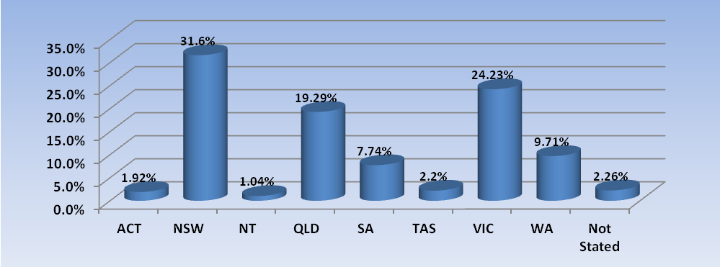
Medical practitioners: age by registration type
Age Group | General | General and Specialist | Specialist | Provisional | Limited |  |  |  | Limited (Public Interest - Occasional Practice) | Non-practising | Total | % By Age Group
 |  |  |  |  | Area of need | Postgraduate training or supervised practice | Public interest | Teaching or research
21 - 25 | 126 |  |  | 633 | 21 | 8 |  |  |  |  | 788 | 0.86%
26 - 30 | 6,512 | 14 | 11 | 1,815 | 600 | 640 |  | 2 |  | 58 | 9,652 | 10.52%
31 - 35 | 8,431 | 1,540 | 281 | 519 | 409 | 877 |  | 9 | 1 | 152 | 12,219 | 13.32%
36 - 40 | 4,442 | 5,348 | 969 | 176 | 390 | 938 |  | 7 | 2 | 260 | 12,532 | 13.66%
41 - 45 | 2,248 | 6,398 | 1,480 | 82 | 347 | 470 | 2 | 2 | 9 | 223 | 11,261 | 12.27%
46 - 50 | 1,538 | 6,623 | 1,498 | 45 | 213 | 193 | 1 | 3 | 11 | 194 | 10,319 | 11.25%
51 - 55 | 1,145 | 7,168 | 1,072 | 19 | 135 | 75 | 3 |  | 13 | 250 | 9,880 | 10.77%
56 - 60 | 843 | 6,630 | 670 | 9 | 87 | 32 | 2 | 2 | 25 | 195 | 8,495 | 9.26%
61 - 65 | 522 | 5,233 | 347 | 1 | 53 | 12 | 3 | 2 | 44 | 190 | 6,407 | 6.98%
66 - 70 | 353 | 3,838 | 156 |  | 15 | 4 | 3 |  | 157 | 231 | 4,757 | 5.19%
71 - 75 | 225 | 2,000 | 55 |  | 6 |  |  |  | 241 | 213 | 2,740 | 2.99%
76 - 80 | 113 | 873 | 19 |  | 1 |  |  |  | 232 | 188 | 1,426 | 1.55%
81 - 85 | 66 | 399 | 5 |  | 1 |  |  |  | 230 | 128 | 829 | 0.9%
86 + | 35 | 141 | 1 |  |  |  |  |  | 135 | 109 | 421 | 0.46%
Not Supplied or Overseas | 5 | 10 |  |  |  |  |  |  | 1 | 3 | 19 | 0.02%
Total | 26,604 | 46,215 | 6,564 | 3,299 | 2,278 | 3,249 | 14 | 27 | 1,101 | 2,394 | 91,745

% By age group
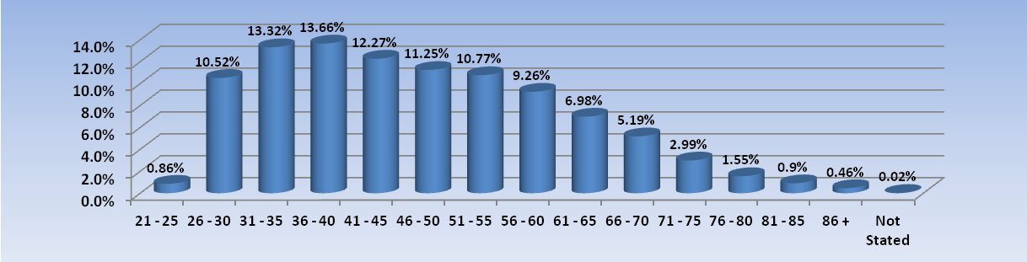
Medical practitioners: gender by state and territory by registration type
Sex | State | General | General and Specialist | Specialist | Provisional | Limited |  |  |  | Limited (Public Interest - Occasional Practice) | Non-practising | Total Count | % By Sex By State
 |  |  |  |  |  | Area of need | Postgraduate training or supervised practice | Public interest | Teaching or research
Female | ACT | 267 | 326 | 43 | 42 | 7 | 31 |  | 1 | 10 | 12 | 739 | 0.81%
Female | NSW | 4,201 | 5,020 | 473 | 551 | 57 | 607 | 1 | 2 | 119 | 238 | 11,269 | 12.28%
Female | NT | 198 | 149 | 30 | 32 | 34 | 7 |  |  |  | 5 | 455 | 0.5%
Female | QLD | 2,536 | 2,699 | 551 | 378 | 369 | 87 |  |  | 17 | 83 | 6,720 | 7.32%
Female | SA | 965 | 1,199 | 137 | 150 | 27 | 163 |  | 3 |  | 44 | 2,688 | 2.93%
Female | TAS | 260 | 372 | 58 | 37 | 16 | 34 |  |  | 5 | 18 | 800 | 0.87%
Female | VIC | 3,286 | 4,028 | 410 | 450 | 80 | 400 |  | 2 |  | 197 | 8,853 | 9.65%
Female | WA | 1,235 | 1,296 | 290 | 174 | 313 | 62 | 2 | 4 | 49 | 76 | 3,501 | 3.82%
Female | Not Supplied or Overseas | 216 | 125 | 80 | 2 | 2 | 3 |  |  | 2 | 247 | 677 | 0.74%
Female | Sub total | 13,164 | 15,214 | 2,072 | 1,816 | 905 | 1,394 | 3 | 12 | 202 | 920 | 35,702 | 38.91%
Male | ACT | 266 | 540 | 84 | 36 | 12 | 42 | 1 |  | 25 | 19 | 1,025 | 1.12%
Male | NSW | 4,218 | 10,419 | 970 | 438 | 125 | 742 | 1 | 5 | 459 | 347 | 17,724 | 19.32%
Male | NT | 156 | 193 | 68 | 17 | 58 | 6 | 1 |  |  | 3 | 502 | 0.55%
Male | QLD | 2,948 | 5,587 | 1,188 | 338 | 478 | 161 | 2 | 7 | 132 | 137 | 10,978 | 11.97%
Male | SA | 947 | 2,637 | 307 | 125 | 73 | 230 | 1 |  | 1 | 83 | 4,404 | 4.8%
Male | TAS | 242 | 664 | 135 | 42 | 40 | 34 | 1 |  | 37 | 26 | 1,221 | 1.33%
Male | VIC | 3,126 | 7,929 | 900 | 357 | 226 | 513 |  | 1 | 6 | 319 | 13,377 | 14.58%
Male | WA | 1,166 | 2,661 | 630 | 126 | 351 | 119 | 3 | 2 | 232 | 113 | 5,403 | 5.89%
Male | Not Supplied or Overseas | 362 | 369 | 209 | 4 | 9 | 7 | 1 |  | 7 | 427 | 1,395 | 1.52%
Male | Sub total | 13,431 | 30,999 | 4,491 | 1,483 | 1,372 | 1,854 | 11 | 15 | 899 | 1,474 | 56,029 | 61.07%
Not Stated | ACT |  | 1 |  |  |  |  |  |  |  |  | 1 | 0.0%
Not Stated | NSW |  | 1 |  |  |  |  |  |  |  |  | 1 | 0.0%
Not Stated | QLD | 1 |  | 1 |  |  |  |  |  |  |  | 2 | 0.0%
Not Stated | SA | 5 |  |  |  |  |  |  |  |  |  | 5 | 0.01%
Not Stated | VIC | 2 |  |  |  |  | 1 |  |  |  |  | 3 | 0.0%
Not Stated | WA | 1 |  |  |  | 1 |  |  |  |  |  | 2 | 0.0%
Not Stated | Sub total | 9 | 2 | 1 |  | 1 | 1 |  |  |  |  | 14 | 0.02%
Total |  | 26,604 | 46,215 | 6,564 | 3,299 | 2,278 | 3,249 | 14 | 27 | 1,101 | 2,394 | 91,745

Medical practitioners: endorsement type by state and territory
Endorsement | NSW | QLD | SA | TAS | VIC | WA | Total
Acupuncture | 10 | 15 | 1 | 6 | 227 | 11 | 270
Total | 10 | 15 | 1 | 6 | 227 | 11 | 270

