Australian Health Practitioner Regulation Agency
e-mail medboardconsultation@ahpra.gov.au

Dear Sir/Madam,

I am writing to express my concern about the draft revised code of conduct, Good medical practice: A code of conduct for doctors in Australia, specifically the following content:

4.8 Culturally safe and respectful practice

4.8.2 Respecting diverse cultures, beliefs, gender identities, sexualities and experiences
of people, including among colleagues and team members.

4.8.4 Adopting practices that respect diversity, avoid bias, discrimination and racism,
and challenge belief based on assumption (for example, based on gender,
disability, race, ethnicity, religion, sexuality, age or political beliefs).

These clauses may be taken to mean that doctors should always accept the beliefs of their patients. The problem is that many people have false beliefs which lead to their own physical and mental harm or even death. In particular, false beliefs are a defining symptom of psychosis, which may lead to self-harm or suicide.

People suffering from delusions about themselves need psychiatric help, not to have their false beliefs accepted. As an example, people with Anorexia Nervosa may continue to believe they are overweight until they die from starvation. As another example, people with Body Integrity Identity Disorder may feel compelled to have their own healthy limbs amputated. It would be the height of irresponsibility for a doctor to accept such false beliefs or compulsions in the name of ‘respect’.

Recently some people have claimed to be trans-gender, trans-racial or even trans-species. An IQ² Debate on the proposition Society Must Recognize Trans People’s Gender Identities was held at The St James Ethics Centre in Sydney in 2016. Philosophy Professor John Haldane argued against the proposition and said the following:

“To resolve issues of sex and sexuality in human nature we need to proceed rigorously and respectfully, bringing to bear both the impartiality of science and philosophy and the partiality
of empathy, imagination and human sensitivity. …

Identities are constituted in a wide variety of ways. Claims to identity are not self-confirming.
The fact that someone claims an identity does not confirm that identity. In June 2015 a 37 year old civil rights activist, Rachel [Dolezal], claimed to be black even though she is white. Her parents said “She is our birth-daughter. We are puzzled by what she now claims to be. Rachel has wanted to be someone and something she is not.” …

Toleration [of differences] is not endorsement, approbation or celebration.”

The following images illustrate the case Professor Haldane cited.

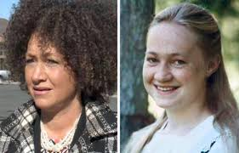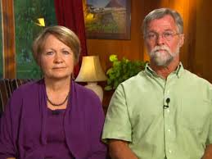

Ms Dolezal after and before she changed Ms Dolezal’s parents being interviewed
her appearance to match her belief. about their daughter.

The code of conduct must allow doctors to base the treatment of their patients on the impartiality of scientific facts. This would not prevent doctors having the partiality of empathy for their patients’ feelings. Doctors must retain the right and responsibility to challenge beliefs for the sake of their patients’ health. The alternative would simply result in malpractice.

Yours faithfully,

Ian Morland
CONTENT REDACTED
CONTENT REDACTED
3 August 2018

