

Medical Board of Australia

Registrant data

Reporting period: 1 October 2017 – 31 December 2017

Table of contents
Introduction 3
Medical practitioners by state and territory 4
1. Registration type 4
2. Specialist registration 5
3. Endorsements by type 8
Medical practitioners by age group 9
4. Age by registration type 9
Medical practitioners by gender 11
5. Gender by registration type 11
6. Gender percentages 12

Introduction
The role of the Medical Board of Australia (the Board) is to:
- register medical practitioners and medical students
- develop standards, codes and guidelines for the medical profession
- investigate notifications and complaints
- where necessary, conduct panel hearings and refer serious matters to Tribunal hearings
- oversee the assessment of overseas trained practitioners who wish to practise in Australia, and
- approve accreditation standards and accredited courses of study.
The Board’s functions are supported by the Australian Health Practitioner Regulation Agency (AHPRA). For information about legislation governing our operations see About AHPRA at http://www.ahpra.gov.au/About-AHPRA/What-We-Do/Legislation.aspx.
The Board has analysed its registration data and produced a number of statistical breakdowns about registrants to share with the profession and community. The Board shares these breakdowns quarterly.
For more information on medical registration, please see the Board’s website: http://www.medicalboard.gov.au/Registration.aspx

Medical practitioners by state and territory
- Registration type
  - Medical practitioners – registration type by state or territory
Registration Type | Registration Sub-type | ACT | NSW | NT | QLD | SA | TAS | VIC | WA | No PPP | Total
General |  | 719 | 12,025 | 527 | 7,858 | 2,515 | 673 | 9,105 | 3,765 | 789 | 37,976
General (Teaching and Assessing) (TA) |  |  | 10 |  | 11 | 1 | 3 | 12 | 2 |  | 39
General TA and Specialist |  |  | 1 |  |  |  |  |  |  |  | 1
General and Specialist |  | 980 | 16,950 | 474 | 9,971 | 4,082 | 1,131 | 13,534 | 4,587 | 720 | 52,429
Specialist |  | 184 | 2,081 | 122 | 2,350 | 596 | 231 | 1,941 | 1,485 | 484 | 9,474
Provisional |  | 105 | 1,501 | 85 | 1,254 | 459 | 114 | 1,160 | 702 | 67 | 5,447
Limited | Postgraduate training or supervised practice | 30 | 604 | 20 | 246 | 136 | 55 | 431 | 197 | 24 | 1,743
Limited | Area of need | 6 | 80 | 29 | 106 | 43 | 28 | 281 | 116 | 1 | 690
Limited | Public interest |  | 1 |  |  |  |  |  |  |  | 1
Limited | Teaching or research |  | 9 |  | 7 | 4 |  | 2 | 7 | 2 | 31
Non-practising |  | 32 | 714 | 11 | 283 | 140 | 52 | 525 | 211 | 833 | 2,801
Total |  | 2,056 | 33,976 | 1,268 | 22,086 | 7,976 | 2,287 | 26,991 | 11,072 | 2,920 | 110,632
  - Medical practitioners – percentage by state or territory
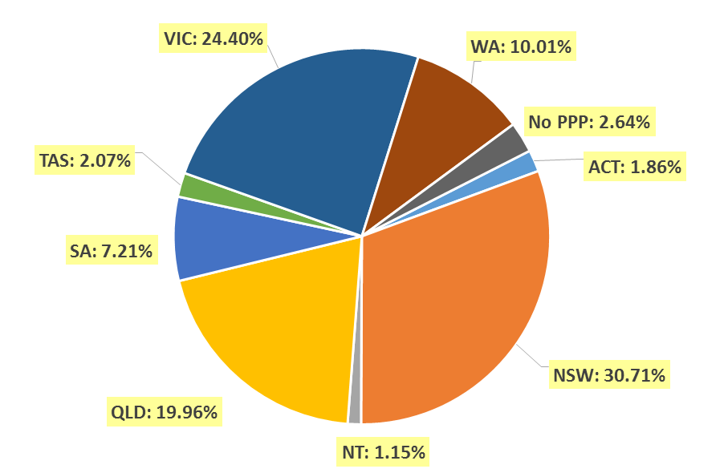
- Specialist registration
  - Medical practitioners – by area of specialist practice
Specialty name | Field of specialty practice | ACT | NSW | NT | QLD | SA | TAS | VIC | WA | No PPP | Total
Addiction medicine |  | 4 | 68 | 2 | 30 | 16 | 6 | 29 | 16 | 4 | 175
Anaesthesia |  | 81 | 1,478 | 36 | 1,016 | 368 | 113 | 1,164 | 548 | 136 | 4,940
Dermatology |  | 6 | 192 | 2 | 94 | 44 | 6 | 146 | 44 | 9 | 543
Emergency medicine |  | 41 | 557 | 44 | 500 | 127 | 48 | 527 | 243 | 72 | 2,159
General practice |  | 467 | 7,676 | 292 | 5,424 | 1,960 | 640 | 6,045 | 2,649 | 222 | 25,375
Intensive care medicine | No sub-specialty declared | 23 | 249 | 11 | 194 | 69 | 18 | 206 | 78 | 35 | 883
Intensive care medicine | Paediatric intensive care medicine |  | 3 |  | 4 |  | 1 | 4 |  |  | 12
Subtotal - Intensive care medicine |  | 23 | 252 | 11 | 198 | 69 | 19 | 210 | 78 | 35 | 895
Medical administration |  | 10 | 101 | 4 | 81 | 15 | 8 | 67 | 25 | 12 | 323
Obstetrics and gynaecology | Gynaecological oncology |  | 15 |  | 10 | 4 | 1 | 12 | 4 |  | 46
Obstetrics and gynaecology | Maternal-fetal medicine | 1 | 11 | 1 | 10 | 3 |  | 9 | 5 | 1 | 41
Obstetrics and gynaecology | Obstetrics and gynaecological ultrasound |  | 13 |  | 3 | 3 |  | 44 | 3 | 2 | 68
Obstetrics and gynaecology | Reproductive endocrinology and infertility |  | 26 |  | 3 | 7 | 1 | 14 | 2 |  | 53
Obstetrics and gynaecology | Urogynaecology | 1 | 10 |  | 7 | 1 |  | 7 | 5 |  | 31
Obstetrics and gynaecology | No sub-specialty declared | 37 | 490 | 13 | 364 | 128 | 38 | 449 | 158 | 48 | 1,725
Subtotal - Obstetrics and gynaecology |  | 39 | 565 | 14 | 397 | 146 | 40 | 535 | 177 | 51 | 1,964
Occupational and environmental medicine |  | 17 | 90 | 1 | 41 | 28 | 5 | 63 | 47 | 9 | 301
Ophthalmology |  | 15 | 368 | 7 | 163 | 70 | 23 | 249 | 79 | 19 | 993
Continued on next page

Specialty name | Field of specialty practice | ACT | NSW | NT | QLD | SA | TAS | VIC | WA | No PPP | Total
Paediatrics and child health | Clinical genetics |  | 17 |  | 5 | 1 |  | 8 | 2 |  | 33
Paediatrics and child health | Community child health | 3 | 27 |  | 14 | 2 | 1 | 14 | 4 | 1 | 66
Paediatrics and child health | General paediatrics | 29 | 639 | 25 | 364 | 136 | 32 | 467 | 192 | 34 | 1,918
Paediatrics and child health | Neonatal and perinatal medicine | 7 | 47 |  | 30 | 14 | 3 | 49 | 29 | 5 | 184
Paediatrics and child health | Paediatric cardiology |  | 9 | 1 | 8 |  |  | 10 | 5 | 7 | 40
Paediatrics and child health | Paediatric clinical pharmacology |  | 1 |  |  |  |  |  |  |  | 1
Paediatrics and child health | Paediatric emergency medicine |  | 12 | 1 | 22 | 5 |  | 12 | 12 | 1 | 65
Paediatrics and child health | Paediatric endocrinology | 1 | 12 | 1 | 9 | 2 |  | 3 | 5 | 1 | 34
Paediatrics and child health | Paediatric gastroenterology and hepatology |  | 6 |  | 5 | 1 |  | 11 | 6 | 2 | 31
Paediatrics and child health | Paediatric haematology |  | 5 |  | 4 | 1 |  | 3 | 3 | 1 | 17
Paediatrics and child health | Paediatric immunology and allergy | 1 | 9 |  | 4 | 8 |  | 10 |  |  | 32
Paediatrics and child health | Paediatric infectious diseases |  | 5 | 1 | 7 | 2 |  | 6 | 4 | 2 | 27
Paediatrics and child health | Paediatric intensive care medicine |  | 3 |  | 3 |  |  |  |  |  | 6
Paediatrics and child health | Paediatric medical oncology |  | 7 |  | 10 | 1 |  | 9 | 7 | 2 | 36
Paediatrics and child health | Paediatric nephrology |  | 4 |  | 1 | 1 |  | 4 | 1 |  | 11
Paediatrics and child health | Paediatric neurology |  | 19 |  | 6 | 1 | 1 | 8 | 2 | 3 | 40
Paediatrics and child health | Paediatric nuclear medicine |  | 1 |  |  |  |  |  |  |  | 1
Paediatrics and child health | Paediatric palliative medicine |  | 2 |  | 2 |  |  | 2 |  |  | 6
Paediatrics and child health | Paediatric rehabilitation medicine |  | 4 |  | 2 | 1 |  |  | 2 |  | 9
Paediatrics and child health | Paediatric respiratory and sleep medicine | 2 | 11 |  | 11 | 1 |  | 4 | 6 |  | 35
Paediatrics and child health | Paediatric rheumatology |  | 3 |  | 2 | 1 |  | 2 | 3 |  | 11
Paediatrics and child health | No sub-specialty declared | 2 | 36 | 7 | 15 | 11 | 3 | 51 | 20 | 16 | 161
Subtotal - Paediatrics and child health |  | 45 | 879 | 36 | 524 | 189 | 40 | 673 | 303 | 75 | 2,764
Continued on next page

Specialty name | Field of specialty practice |  | ACT | NSW | NT | QLD | SA | TAS | VIC | WA | No PPP | Total
Pain medicine |  |  | 4 | 95 |  | 55 | 31 | 11 | 61 | 33 | 2 | 292
Palliative medicine |  |  | 4 | 115 | 4 | 62 | 27 | 12 | 74 | 33 | 6 | 337
Pathology |  | Anatomical pathology (incl cytopathology) | 20 | 304 | 7 | 185 | 66 | 19 | 200 | 96 | 15 | 912
 |  | Chemical pathology | 4 | 24 | 1 | 14 | 9 | 2 | 18 | 14 | 3 | 89
 |  | Forensic pathology |  | 10 |  | 16 | 5 | 2 | 13 | 5 |  | 51
 |  | General pathology | 1 | 48 |  | 19 | 4 | 3 | 20 | 6 | 2 | 103
 |  | Haematology | 12 | 174 | 2 | 97 | 42 | 12 | 137 | 46 | 12 | 534
 |  | Immunology | 6 | 47 |  | 12 | 10 |  | 21 | 19 | 1 | 116
 |  | Microbiology | 7 | 84 | 1 | 41 | 17 | 5 | 44 | 36 | 3 | 238
 |  | No sub-specialty declared | 2 | 18 |  | 8 | 3 |  | 6 | 8 | 3 | 48
Subtotal - Pathology |  |  | 52 | 709 | 11 | 392 | 156 | 43 | 459 | 230 | 39 | 2,091
Physician |  | Cardiology | 19 | 437 | 9 | 276 | 114 | 21 | 358 | 89 | 44 | 1,367
 |  | Clinical genetics |  | 31 |  | 7 | 9 |  | 20 | 3 |  | 70
 |  | Clinical pharmacology |  | 16 |  | 10 | 12 |  | 12 | 5 | 3 | 58
 |  | Endocrinology | 14 | 235 | 7 | 125 | 39 | 10 | 216 | 55 | 3 | 704
 |  | Gastroenterology and hepatology | 23 | 265 | 4 | 163 | 64 | 14 | 250 | 71 | 23 | 877
 |  | General medicine | 30 | 372 | 23 | 383 | 231 | 36 | 518 | 145 | 37 | 1,775
 |  | Geriatric medicine | 14 | 234 | 2 | 101 | 61 | 11 | 226 | 84 | 5 | 738
 |  | Haematology | 11 | 176 | 3 | 98 | 39 | 14 | 169 | 40 | 15 | 565
 |  | Immunology and allergy | 7 | 63 | 1 | 14 | 11 | 2 | 33 | 26 | 4 | 161
 |  | Infectious diseases | 10 | 104 | 11 | 67 | 33 | 8 | 164 | 37 | 11 | 445
 |  | Medical oncology | 12 | 204 | 3 | 112 | 48 | 14 | 233 | 41 | 17 | 684
 |  | Nephrology | 13 | 170 | 13 | 91 | 27 | 10 | 173 | 42 | 14 | 553
 |  | Neurology | 10 | 219 | 1 | 80 | 37 | 8 | 194 | 44 | 11 | 604
 |  | Nuclear medicine | 8 | 104 |  | 28 | 24 | 7 | 59 | 22 | 1 | 253
 |  | Respiratory and sleep medicine | 11 | 221 | 1 | 132 | 60 | 13 | 179 | 71 | 9 | 697
 |  | Rheumatology | 11 | 121 | 1 | 52 | 37 | 8 | 110 | 30 | 7 | 377
 |  | No sub-specialty declared | 4 | 110 | 4 | 31 | 6 | 7 | 49 | 54 | 15 | 280
Subtotal - Physician |  |  | 197 | 3,082 | 83 | 1,770 | 852 | 183 | 2,963 | 859 | 219 | 10,208
Continued on next page
Specialty name | Field of specialty practice | ACT | NSW | NT | QLD | SA | TAS | VIC | WA | No PPP | Total
Psychiatry |  | 55 | 1,117 | 22 | 704 | 291 | 72 | 1,002 | 338 | 79 | 3,680
Public health medicine |  | 31 | 127 | 23 | 77 | 26 | 10 | 76 | 41 | 12 | 423
Radiation Oncology |  | 13 | 137 | 2 | 78 | 17 | 8 | 98 | 23 | 8 | 384
Radiology | Diagnostic radiology | 44 | 611 | 2 | 402 | 159 | 40 | 501 | 223 | 109 | 2,091
Radiology | Diagnostic ultrasound |  |  |  | 2 |  |  | 3 |  |  | 5
Radiology | Nuclear medicine | 6 | 37 |  | 50 | 10 | 2 | 66 | 11 | 3 | 185
Radiology | No sub-specialty declared | 8 | 53 |  | 16 | 5 | 2 | 56 | 24 | 18 | 182
Subtotal - Radiology |  | 58 | 701 | 2 | 470 | 174 | 44 | 626 | 258 | 130 | 2,463
Rehabilitation medicine |  | 7 | 232 | 2 | 67 | 39 | 10 | 138 | 15 | 10 | 520
Sexual health medicine |  | 4 | 54 | 1 | 21 | 10 | 2 | 25 | 8 | 2 | 127
Sport and exercise medicine |  | 12 | 41 | 1 | 10 | 4 | 2 | 38 | 10 | 1 | 119
Surgery | Cardio-thoracic surgery | 4 | 55 |  | 42 | 12 | 3 | 59 | 15 | 8 | 198
Surgery | General surgery | 29 | 656 | 23 | 367 | 163 | 34 | 534 | 154 | 48 | 2,008
Surgery | Neurosurgery | 7 | 78 | 1 | 52 | 16 | 7 | 68 | 19 | 5 | 253
Surgery | Oral and maxillofacial surgery | 3 | 31 | 2 | 34 | 13 | 2 | 32 | 13 | 7 | 137
Surgery | Orthopaedic surgery | 26 | 442 | 6 | 311 | 120 | 27 | 319 | 133 | 35 | 1,419
Surgery | Otolaryngology - head and neck surgery | 8 | 166 | 2 | 94 | 45 | 9 | 123 | 42 | 13 | 502
Surgery | Paediatric surgery | 4 | 35 |  | 16 | 8 | 2 | 22 | 8 | 3 | 98
Surgery | Plastic surgery | 5 | 127 | 2 | 69 | 43 | 10 | 144 | 46 | 7 | 453
Surgery | Urology | 7 | 132 | 1 | 88 | 34 | 12 | 125 | 40 | 7 | 446
Surgery | Vascular surgery | 3 | 76 | 2 | 46 | 18 | 4 | 64 | 19 | 3 | 235
Surgery | No sub-specialty declared |  | 24 | 1 |  |  |  | 11 | 5 | 2 | 43
Subtotal - Surgery |  | 96 | 1,822 | 40 | 1,119 | 472 | 110 | 1,501 | 494 | 138 | 5,792
Total |  | 1,281 | 20,458 | 640 | 13,293 | 5,131 | 1,455 | 16,769 | 6,551 | 1,290 | 66,868

- Endorsements by type
  - Medical practitioners – endorsements by state or territory
Endorsement | ACT | NSW | NT | QLD | SA | TAS | VIC | WA | No PPP | Total
Acupuncture | 6 | 164 | 3 | 94 | 32 | 14 | 230 | 36 |  | 579

Medical practitioners by age group
- Age by registration type
  - Medical practitioners – registration type by age group
Age group | General | General (TA) | General and Specialist | General (TA) and Specialist | Specialist | Provisional | Limited | Non-practicing | Total
U - 25 | 120 |  |  |  |  | 806 |  |  | 926
25 - 29 | 9,636 |  | 83 |  | 8 | 3,055 | 64 | 65 | 12,911
30 - 34 | 11,811 | 2 | 1,884 |  | 227 | 814 | 573 | 207 | 15,518
35 - 39 | 6,524 | 3 | 6,184 |  | 959 | 441 | 804 | 198 | 15,113
40 - 44 | 3,286 |  | 7,719 |  | 1,933 | 185 | 502 | 221 | 13,846
45 - 49 | 2,004 | 1 | 7,222 | 1 | 2,088 | 82 | 269 | 213 | 11,880
50 - 54 | 1,443 | 5 | 6,889 |  | 1,801 | 35 | 142 | 219 | 10,534
55 - 59 | 1,140 | 6 | 7,086 |  | 1,225 | 16 | 69 | 270 | 9,812
60 - 64 | 786 | 5 | 6,275 |  | 719 | 7 | 29 | 282 | 8,103
65 - 69 | 477 | 6 | 4,444 |  | 328 | 4 | 10 | 279 | 5,548
70 - 74 | 337 | 7 | 2,819 |  | 139 | 2 | 2 | 302 | 3,608
75 - 79 | 222 | 3 | 1,206 |  | 37 |  | 1 | 258 | 1,727
80+ | 190 | 1 | 618 |  | 10 |  |  | 287 | 1,106
Total | 37,976 | 39 | 52,429 | 1 | 9,474 | 5,447 | 2,465 | 2,801 | 110,632

  - Medical practitioners – by age group
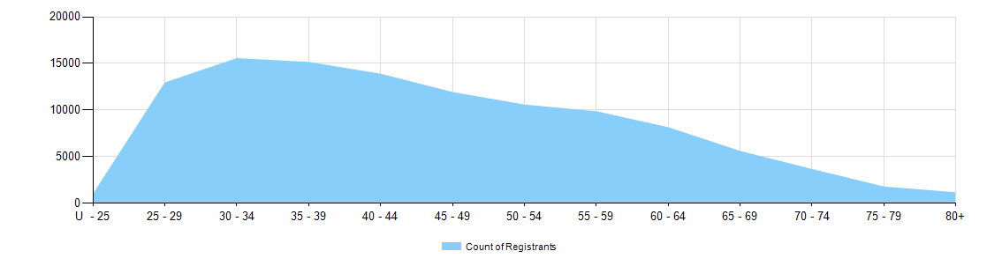

  - Medical practitioners – limited registration by age group
Medical practitioners | Limited registration
Age group | Area of need | Postgraduate training or supervised practice | Public interest | Teaching or research | Total
U - 25
25 - 29 | 5 | 57 |  | 2 | 64
30 - 34 | 98 | 468 |  | 7 | 573
35 - 39 | 170 | 631 |  | 3 | 804
40 - 44 | 162 | 333 |  | 7 | 502
45 - 49 | 111 | 155 | 1 | 2 | 269
50 - 54 | 85 | 52 |  | 5 | 142
55 - 59 | 34 | 34 |  | 1 | 69
60 - 64 | 19 | 8 |  | 2 | 29
65 - 69 | 4 | 4 |  | 2 | 10
70 - 74 | 1 | 1 |  |  | 2
75 - 79 | 1 |  |  |  | 1
80+
Total | 690 | 1,743 | 1 | 31 | 2,465

Medical practitioners by gender
- Gender by registration type
  - Medical practitioners – gender by state and territory by registration type
Gender | Registration type | Registration subtype | ACT | NSW | NT | QLD | SA | TAS | VIC | WA | No PPP | Total
Female | General |  | 387 | 6,149 | 275 | 3,863 | 1,308 | 352 | 4,788 | 1,993 | 340 | 19,455
Female | General (TA) |  |  | 8 |  | 3 | 1 | 2 | 4 | 1 |  | 19
Female | General TA and Specialist |  |  | 1 |  |  |  |  |  |  |  | 1
Female | General and Specialist |  | 402 | 6,150 | 231 | 3,592 | 1,447 | 438 | 5,062 | 1,657 | 234 | 19,213
Female | Specialist |  | 71 | 744 | 37 | 787 | 189 | 77 | 663 | 507 | 139 | 3,214
Female | Provisional |  | 63 | 735 | 55 | 593 | 252 | 49 | 590 | 361 | 30 | 2,728
Female | Limited | Postgraduate training or supervised practice | 8 | 240 | 6 | 100 | 45 | 18 | 175 | 82 | 11 | 685
Female | Limited | Area of need | 3 | 34 | 12 | 35 | 19 | 11 | 111 | 47 |  | 272
Female | Limited | Teaching or research |  | 1 |  | 1 | 1 |  | 1 | 7 | 1 | 12
Female | Non-practising |  | 13 | 318 | 6 | 120 | 55 | 23 | 210 | 92 | 363 | 1,200
Total female |  |  | 947 | 14,380 | 622 | 9,094 | 3,317 | 970 | 11,604 | 4,747 | 1,118 | 46,799
Male | General |  | 332 | 5,876 | 252 | 3,995 | 1,207 | 321 | 4,317 | 1,772 | 449 | 18,521
Male | General TA |  |  | 2 |  | 8 |  | 1 | 8 | 1 |  | 20
Male | General TA and Specialist
Male | General and Specialist |  | 578 | 10,800 | 243 | 6,379 | 2,635 | 693 | 8,472 | 2,930 | 486 | 33,216
Male | Specialist |  | 113 | 1,337 | 85 | 1,563 | 407 | 154 | 1,278 | 978 | 345 | 6,260
Male | Provisional |  | 42 | 766 | 30 | 661 | 207 | 65 | 570 | 341 | 37 | 2,719
Male | Limited | Postgraduate training or supervised practice | 22 | 364 | 14 | 146 | 91 | 37 | 256 | 115 | 13 | 1,058
Male | Limited | Area of need | 3 | 46 | 17 | 71 | 24 | 17 | 170 | 69 | 1 | 418
Male | Limited | Public interest |  | 1 |  |  |  |  |  |  |  | 1
Male | Limited | Teaching or research |  | 8 |  | 6 | 3 |  | 1 |  | 1 | 19
Male | Non-practising |  | 19 | 396 | 5 | 163 | 85 | 29 | 315 | 119 | 470 | 1,601
Total male |  |  | 1,109 | 19,596 | 646 | 12,992 | 4,659 | 1,317 | 15,387 | 6,325 | 1,802 | 63,833
Total |  |  | 2,056 | 33,976 | 1,268 | 22,086 | 7,976 | 2,287 | 26,991 | 11,072 | 2,920 | 110,632
- Gender percentages
  - Medical practitioners – percentage by gender
Gender | ACT | NSW | NT | QLD | SA | TAS | VIC | WA | No PPP | Total
Female | 46.1% | 42.3% | 49.1% | 41.2% | 41.6% | 42.4% | 43.0% | 42.9% | 38.3% | 42.3%
Male | 53.9% | 57.7% | 50.9% | 58.8% | 58.4% | 57.6% | 57.0% | 57.1% | 61.7% | 57.7%

